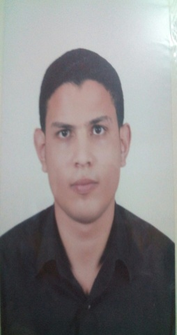

Ibrahem
Call Center agent

Personal information
Full name | Ibrahem
Birth date | 06/05/1989
Nationality | Egyptian
Material status | Single
Military service | Performed
Contact | Whatsapp +971504753686 / +919979971283
 | ibrahem.376211@2freemail.com

ــــــــــــــــــــــــــــــــــــــــــــــــــــــــــــــــــــــــــــــــــــــــــــــــــــــــــــــــــــــــــــــــــــــــــــــــــــــــــــــــــــــــــــــــــــــــــــــــــــــ
EDUCATION:

Mansoura University, Mansoura, Egypt
Faculty Of Computer Science And Information System (CIS)
Information System (IS) ==> 2006-2010
ــــــــــــــــــــــــــــــــــــــــــــــــــــــــــــــــــــــــــــــــــــــــــــــــــــــــــــــــــــــــــــــــــــــــــــــــــــــــــــــــــــــــــــــــــــــــــــــــــــــ
Experience

1 : Call center agent (etisalat misr 333 account etisal international)
Two years 2015 == 2017

Responsibility
- Obtains client information by answering telephone calls; interviewing clients; verifying information.
- Determines eligibility by comparing client information to requirements.
- Establishes policies by entering client information; confirming pricing.
- Informs clients by explaining procedures; answering questions; providing information.
- Maintains communication equipment by reporting problems.
- Maintains and improves quality results by adhering to standards and guidelines;
- recommending improved procedures.

2 : IT manager (delta for cotton . Egypt) 3 Years 2011 == 2014

Responsibility
- Manage information technology and computer systems
- Plan, organize, control and evaluate IT and electronic data operations
- Manage IT staff by recruiting, training and coaching employees, communicating job expectations and appraising their performance
- Design, develop, implement and coordinate systems, policies and procedures
- Ensure security of data, network access and backup systems
- Act in alignment with user needs and system functionality to contribute to organizational policy

COURSES:

IT Share Education Center Mansoura
Web design & PHP ==> 4 month 2012

CERTIFICATION:

South Western Accreditation COUNCIL
Conversation Course 10 - April 2012
ـــــــــــــــــــــــــــــــــــــــــــــــــــــــــــــــــــــــــــــــــــــــــــــــــــــــــــــــــــــــــــــــــــــــــــــــــــــــــــــــــــــــــــــــــــــــــــــــــــــ

SKILLS:

Language :
Fluent in Arabic and English
Level 4 at English Conversation

Computer :
Oracle Developer
UI design –Data Entry
Windows – MsOffice .

Personal Skills:
- Ability to be good leadership & control my team work.
- Excellent Communication, Leadership, analytical & organization Skills.
- Ability to work under pressure and meet strict deadlines.
- Very quick learner and like to learn.
- Ability to work in team.

