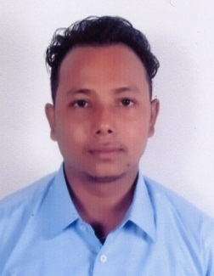
Curriculum vitae
BIJENDRA
D.O.B:- 26th April 1991
Current Address: ABU DHABI.
CONTACT NO : Whatsapp +971504753686 / +919979971283
NATIONALITY : INDIAN.
VISA STATUS : VISIT VISA. Visa Expire on 21th Feb 2018.
Email: bijendra.376244@2freemail.com
CAREER OBJECTIVE
A challenging position in a professional environment, which clear to
Enhanced opportunities in career growth that will best utilize my skills, Knowledge and determination.

EDUCATIONAL QUALIFICATION
10th passed From NIOS In 2010
H.S Passed From NIOS In 2012
BA dropped out Final year from IGNOU in 2015
COMPUTER SKILLS
- Diploma In Computer Application
- Tally Erp9 Basic Account
- MS Office Application(Word, Excel, Access, Power Point, And Internet Explorer)
- Working with Windows Operating System.

WORK EXPERIENCE
- Data Entry as a Dynamic computer from 2ndFeb 2013 to 9th July 2017.
( 3 years 5 month)
- Working as a computer instructor in Kripan Vocational Training Centre. 31Mar 2012 to 31 Dec 2012. ( 9 month)
JOB DESCRIPTION
- Transfer data from paper formats into computer files or database systems using keyboards, data recorders or optical scanners
- Type in data provided directly from customers
- Create spreadsheets with large numbers of figures without mistakes
- Verify data by comparing it to source documents
- Update existing data
- Retrieve data from the database or electronic files as requested
- Perform regular backups to ensure data preservation
SKILLS
- Good communication and presentation
- Strong planning and leadership

PERSONAL INFORMATION
Name : Bijendra
Nationality : Indian
Gender : Male
Marital status : Unmarried
Languages Known : Hindi, English, Nepali,& Bengali
Visit visa : Visa Issued on 16th nov 2017 - Visa Expire on 21th Feb 2018.
DECLARATION
- I hereby solemnly declare that the above information and particulars are true and correct to the best of my knowledge and belief.
Date:
Place: Bijendra

