Curriculum Vitae
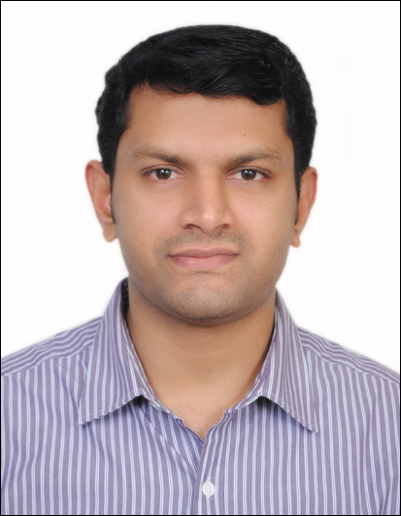
SUDHEERSHA.
Email: sudheersha.376260@2freemail.com
Mob: Whatsapp +971504753686 / +919979971283
Dubai, UAE.

PERSONAL PROFILE:

Self-motivated and hard working, with excellent team working and interpersonal skills a bright and confident individual, who is quick to grasp new skills, whilst performing effectively under pressure to meet tight deadlines An exceptional communicator with excellent written and verbal presentation skills with a talent for effective organization and prioritization of work

Objective:
Intend to build a career with leading corporate of hi-tech environment with committed & dedicated people, which will help me to explore myself and realize my potential. Willing to work as a key player in challenging & creative environment.

Working Experience

Customer Service Officer (Index Exchange Co LLC) from FEB 2012 to till date
- Process the cash transaction like foreign currency exchange, local and international remittance, personal bank account opening and other financial matter and dealing on behalf of client.
- Deliver an error-free customer service aimed at providing an uncompressed satisfaction of the clients but not compromising the policies and procedures.
- Cross-sell financial products and services, while guiding and influencing clients to render or purchase products such as Personal Accident (Privilege Card Membership)
- Adhere to the Anti-Money Laundering (AML) policies, regulatory requirements and other policies of the company and audit compliance of the Central Bank.
- Conducting marketing services, gathering data and market research for prospect clients to Increase the volume of transactions and clientele introduce new products into market and existing clientele.
- Effectively attend complaints / queries and ensures all are dealt accordingly, providing customer with pertinent information regarding their respective inquiries.
- Handled Bank Account Opening Independently
- Well Acquainted to Other customers services / Account Facilitation Operation
- Solve problems items, client complaints and entertain enquiries with almost courtesy and sincerity.
- Investigate notes to determine genuine from counterfeit, balance transactions and ensure that there will be misclassifications.
- Supporting System Networking, installation and troubleshooting.

WAGES PROTECTION SYSTEM (WPS)

Disburse Salaries
- Make agreements between First Party and Second Party.
- Salary account statements for the companies as well as employees.
- Make Registration File, Salary information File and Reports of Employers,
- Handle all the processes for WPS.

Worked as a Web Designer, Developer & Flash Designer, Gazze Media , Thiruvananthapuram from 1st Oct 2009 to 25th November 2011.

Worked as a Web Designer & Flash Designer, The Pixel Studios, Thiruvananthapuram from 1st March 2008 to 30th September 2009.

Worked as a Web Designer & Graphic Designer, Login Knowledge Services Pvt Ltd, Thiruvananthapuram from 1st March 2006 to 30th January 2008.

Worked as a Graphic Designer, CoreTech InfoSystems Pvt Ltd,Thiruvananthapuram from 1st November 2005 to 25th Febraury 2006.

Worked as a Quality Controller (QC) in JVS International Pvt Ltd, Thiruvananthapuram from 17th January 2005 to 15th October 2005.

Worked as a System Administrator in Guru Solutions Pvt Ltd, Nila, Technopark Campus, Thiruvananthapuram From 5th January 2004 to 17th August 2004.

Educational Qualification:

MS University, Tamilnadu 2003
Master’s Degree in Computer Application (MCA)
Kerala University 2000
Bachelor’s Degree in Computer Science (Bsc Computer Science)
VHSE Board Of Kerala 1996
Vocational Subject (MRDA)

SSLC Board Of Kerala -1994

Proficiency in computer

Operating systems : MS DOS, Windows 98/2000/XP, Windows NT
Development tools : PHP, Visual basic 6
Data base : MySQL, Ms Access
Designing tools : Photoshop, PageMaker, CorelDraw
Web tools : HTML, CSS, Dreamweaver, Flash CS3.

Additional Qualification
Web designing course from TCIL IT, Thiruvananthapuram, Kerala.

Web Site
http://www.kinfonets.com/1 (Personal Profile-Sample Site)

Profile:
Name : Sudheersha
Date of birth : 01-06-1979
Sex : Male
Marital status : Married
Religion and caste : Islam-Muslim
Nationality : Indian
Visa Status : Employment
Visa Expire : 15-02-2018
Languages Known : English, Malayalam, Hindi, Tamil

DECLARATION:

I hereby declare that the statements are true to the best of my knowledge.

Sudheersha

