SHIHAB
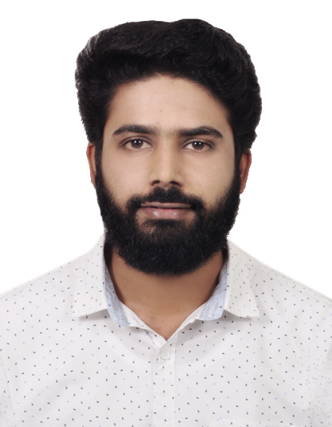
PRESENT-CONTACT DETAILS

DUBAI
E-mail: shibin.376291@2freemail.com
Mobile: Whatsapp +971504753686 / +919979971283
VISA STATUS :-ON VISIT

APPLIED FOR ACCOUNTANT
OBJECTIVE
In my career I predict myself as a vibrant and motivated individual with a strong pursuit of distinction. I will strive hard to improve my performance with every passing day. I have faith in the team work and corporation which is a key to the success in this esteemed organization.
Profile Summary
- Diploma in Indian & Foreign accounting certified from the G-Tec
- Certification of International Association of Book-keerpers(IAB)
- More than 4 years of experience in Accounts and Finance
- Experience of maintaining financial statements up to finalization.
- ERP exposure of TALLY, Peachtree, Quick Books and DAC Easy
- Experience in working under pressure and meeting deadlines.

Work Experience
a

RECEIVING STORE CLERK – January 2016 – January 2017
I have worked as Receiving store clerk at MANZIL DOWNTOWN DUBAI LLC (EMAAR) and involved in:
- Check and upload incoming shipments like food & beverage and other goods.
- Check the quality and quantity food beverage. Insert items into containers.
- Count, weigh or measure items of incoming shipments in order to verify information against invoices, orders , bills of lading or other records
- Route items to various departments.
- Responsible for contacting shippers directly if a problem or discrepancy is found and keeping careful records.
- Making payment arrangements and signing for shipments as well.
ACCOUNTANT – Sept 2015 – December 2015
I have worked as an Accountant in SPEED TRACK GARAGE LLC. DUBAI – Al QOUZ my key responsibilities include
- Responsible for maintenance of proper books of accounts and ledgers.
- Salary preparation of employees both computerized & manually.
- Prepare profit and loss statements and Balance Sheet.
- Controlling petty cash and it will record systematically.
- Perform all other administration work will be the interest of the management

BRANCH MANAGER – January 2017 to Present
I have worked in MAX VALUE CREDIT AND INVESTMENT Ltd, well reputed non-banking financial company in India as a Branch Manager. My key responsibilities include,
- Coordination and direction of operational function of branch.
- Advise customers on various financial products and interview loan applicants.
- Direct regular team/staff meeting.
- Ensure a high level of customer service is being adhered to all times.
- Meet with customers and resolve any problems or complaints.
- Monitor sales target.
Educational Qualification
- Completed Graduation in Bachelor of Commerce at Calicut University.
- Completed Diploma in Indian And Foreign Accounting. (DIFA , IAB)
I T-SKILLS

- Reporting : MS Office – Excel & Power point
- Office Tools : Microsoft Office – Word , Outlook
- Accounting Soft wares : Tally erp9.1 ,VAT, Peach tree ,Quick book, Dac easy
Personnel Details

Age & Date of Birth : 27, 31-12-1990
Gender : Male
Nationality : Indian
Marital Status : Married
Religion : Islam
Languages known : English, Hindi, Malayalam, Tamil
Passport Details : valid till 2021

REFERENCE
Will be furnished up on request
Declaration
I hereby declare that all the details furnished above are true to the best of my knowledge and belief. I am prepared for the next challenge in my career and look forward to hearing from you. Thank you for your time and consideration.
Place: Dubai SHIHAB

