RESUME
Sanoop 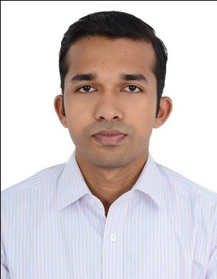
Commissioning Engineer (HVAC)
Mobile : Whatsapp +971504753686 / +919979971283
Email: sanoop.376294@2freemail.com

OBJECTIVE
To be employed in a company where my expertise in the field of engineering and construction could be utilized for mutual benefits
SUMMARY
Working in a leading HVAC Commissioning company in Abu Dhabi, for various projects under project consultants such as ADNOC,GASCO,EMCO since December 2015 to till date. I have got experience in commissioning, estimation and execution of testing and balancing air supply, fresh air handling ,ventilation and chilled water systems .Also include the execution of HVAC system
EXPERIENCE
2015 December – Till date T & C TECHNOLOGY LLC , ABU DHABI
Commissioning Engineer (HVAC)

Duties and Responsibilities:

- Responsible for testing and balancing requirements and validating the commissioned systems

- Handled the tasks of selecting equipment and preparing final commissioning report

- Performed responsibilities of monitoring potential enhancements as well as assists the senior commissioning engineer developing commissioning procedures

- Assigned the tasks of testing equipment and updating commissioning plans to the product manager

- Responsible for preparing field reports, verifying commissioned equipment , and troubleshooting equipment.

- Handled the tasks of preparing initial commissioning process and update the same to the commissioning manager

LIST OF MAJOR PROJECTS HANDLED

- PRESIDENTIAL GUARD COMMAND at Mahwi ,Abu Dhabi MEP by Siedco General Contracting LLC

- RUWAIS HOUSING COMPLEX PHASE : IV at Al Ruwais , Client : ADNOC

- AL JAZEERA TOWER at Abu Dhabi Corniche MEP by Commodore Contracting Company LLC

- AMERICAN COMMUNITY SCHOOL at Al Bateen , Abu Dhabi MEP by Crawford Electromechanical LLC

- CTS-12 - Fitting Building For Infantry at Al Hamra Um Al Ostan, Ruwais , Client : COMMAND OF MILITARY WORKS

- CTS-1-Building at Al Hamra Um Al Ostan, Ruwais , Client : COMMAND OF MILITARY WORKS

- SHAHAMA SLAUGHTER HOUSE at Al Shahama , Abu Dhabi MEP by Hills AC Central Works LLC

- BRITISH SCHOOL ,Al Kubairat at Al Bateen , Abu Dhabi MEP by Crawford Electromechanical LLC

EDUCATION
- 2014 Technology Training And Research Institute Cochin , Kerala

- Expert Program In Automotive Design (CAD/FEA)

- 2010 - 2014 Baselios Mathews II College Of Engineering Kollam , Kerala

- B.Tech in Mechanical Engineering

CAD & IT SKILLS

- Catia V5 R20, Ansys 12.0 , SolidWorks, Auto CAD 2010
- MS Office 2010 (Excel, Word)
- Windows (7 , XP, Vista)
TRAINING PROGRAMS ATTENDED

- Expert Program In Automotive Design (CAD/FEA) from Technology Training & Research Institute, Cochin from July 2014 to September 2014

PERSONAL DETAILS
Date of Birth : August 28 1992
Marital Status : Single
Nationality : Indian
Linguistic Ability : English, Hindi
Driving License : India
Visa Status : Employment

DECLARATION

I do hereby declare that the above written particulars are true to the best of my knowledge and belief.

Sanoop

