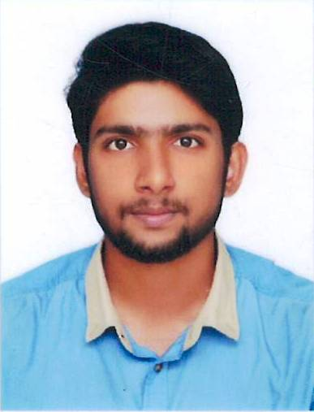
HAMDI
Citizenship: INDIAN | Current city: Dubai | DOB: 08-01-1995
Mobile Number: +971504753686 / +919979971283 |  | Email: hamdi.376300@2freemail.com

Objective | To gain a dynamic and challenging role in the area of Chemical Engineering that will offer me the best opportunity for further development of my abilities, skills and knowledge in an established firm with long term career growth.

Experiences
Internships | - Internship in RCF ltd, Mumbai, India  (Ammonia plant)  - Internship in FACT ltd, Ernakulam, India  (Phosphoric acid plant, Sulphuric acid plant, NPK fertilizer plant, Effluent treatment plant)  (Learned the Mechanism, Operations, Equipment used, Designs, maintenance, safety, raw materials, catalyst used and quality of the products and byproducts obtained in a plant. Did an overall study of a plant in both practical and theoretical approach.)

Project works | Completed Project on the topic “Hydrodynamic studies on fluidized beds with internals”.  Summary: Construction of experimental setup, Conduction of experiments, Data collection, Analysis of data, Development of correlations.  (Correlations for pressure drop and expansion ratio using the dimensionless numbers like Froude number and parameters for the bed, material and internal have been developed and the predicted value using these correlations were compared with the experimental values)

Professional Skills | - MS Office  - MATLAB  - C++ | - AutoCAD  - Aspen Plus

Educational Qualifications
Course | College | University | Year of Passing
B.Tech, Chemical Engineering | Manipal Institute of Technology | Manipal University | 2017
Areas of Interest | Physical chemistry, life science, transport operations, unit operations, chemical reaction engineering.
Electives (Optional Subjects) | Biomechanics, Automotive pollution and control, Oil and gas reservoir engineering, Industrial waste water engineering, Advanced process dynamics and control.

Extra-Curricular Activities
- Organizer of cheminova, techtatva 2014
- Volunteer for chemignite 2k14
- Completed Youth Empowerment and Skills workshop
- Participated in MIT Football league
- Winner of cross country run held by MIT sports club
- Half Marathon finisher
- Winner in Block level Keralotsavam 2017 (Football)

The above information provided by me is true and have all relevant documents to authenticate the same.

HAMDI

