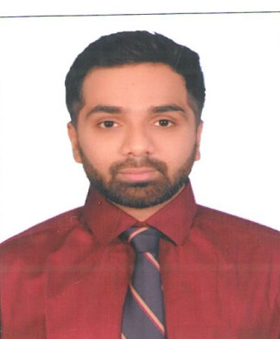
        - SHADAB

- E-Mail: - Shadab.376309@2freemail.com
- Mobile: +971504753686 / +919979971283
- ACADEMIC CREDENTIALS :-
- 2011 - Mumbai University, Passed Bachelor Of Science
- 2008 - Passed Higher Secondary from Maharashtra State Board.
- 2006 - Senior Secondary from Maharashtra State Board

- WORK EXPERIENCE :-
      - INTELENET GLOBAL SERVICES

Company Overview:

Intelenet Global Services is a leading service provider with its headquarters located in Malad (Mumbai).

I was involved in UAE Collections of Cards, Mortgage and Personal Loan which was sourced by ADIB (Abu Dhabi Islamic Bank) in UAE.

- Worked Since: 19th December 2011 till 2nd July 2017
- Job Responsibility:-
- Collecting on accounts which have fallen into collections along with following quality parameters which ensured good collection practices being followed and ensured there are no third party information violations.
- Daily Follow ups for collection of Over Due amount as per the Allocation.
- Adopt different Strategies for the collection at different Point of Time.
- Coordinate with the field team on accounts where customers are not contactable.
- Ensure the customer is treated well during the overdue follow up.
- Skip trace customers of late buckets and recovery through various means which are available like sending emails through team lead, searching various job portal sites, co ordinate with agencies and also check on immigration status.
- Was part of a special team in assisting customers who were going through financial crisis in restricting their debts which helped bank to reduce losses.
- Assisting team lead in understanding various reasons for delinquency which would help strategy team to change collection strategies.
- Assisting team leads in monitoring calls of new agents and giving them appropriate feedback.
- As a senior advisor basis my performance I was chosen to assist the training team in training new batches and get them up the learning curve.
- Ensure the Monthly Collection Target is met.

- OTHER QUALIFICATION
- Well versed with MS office.
- Well versed with Internet and E-Mail applications.

- PERSONAL DETAILS
- Date of birth : 12th December 1990
- Gender : Male.
- Nationality : INDIAN
- Language Known : English & Hindi.

- ATTRIBUTES

- Flexibility and Willingness to Learn.
- I relate well with people.
- Team player and Self motivator.
- Dedicated, Hard working, Full of Endurance & Result Oriented.

- I assure you that if given a chance to prove my abilities, I shall give my best.
- I certify that to the best of my knowledge and belief, this CV correctly describes me and my qualification.

- (SHADAB)

