Younes

+971504753686 / +919979971283
Younes.376315@2freemail.com

Permis B, Personal vehicle

Languages

Other
Hospitality and Tourism Cultural centers and Museums Administration and Secretarial Education and Teaching
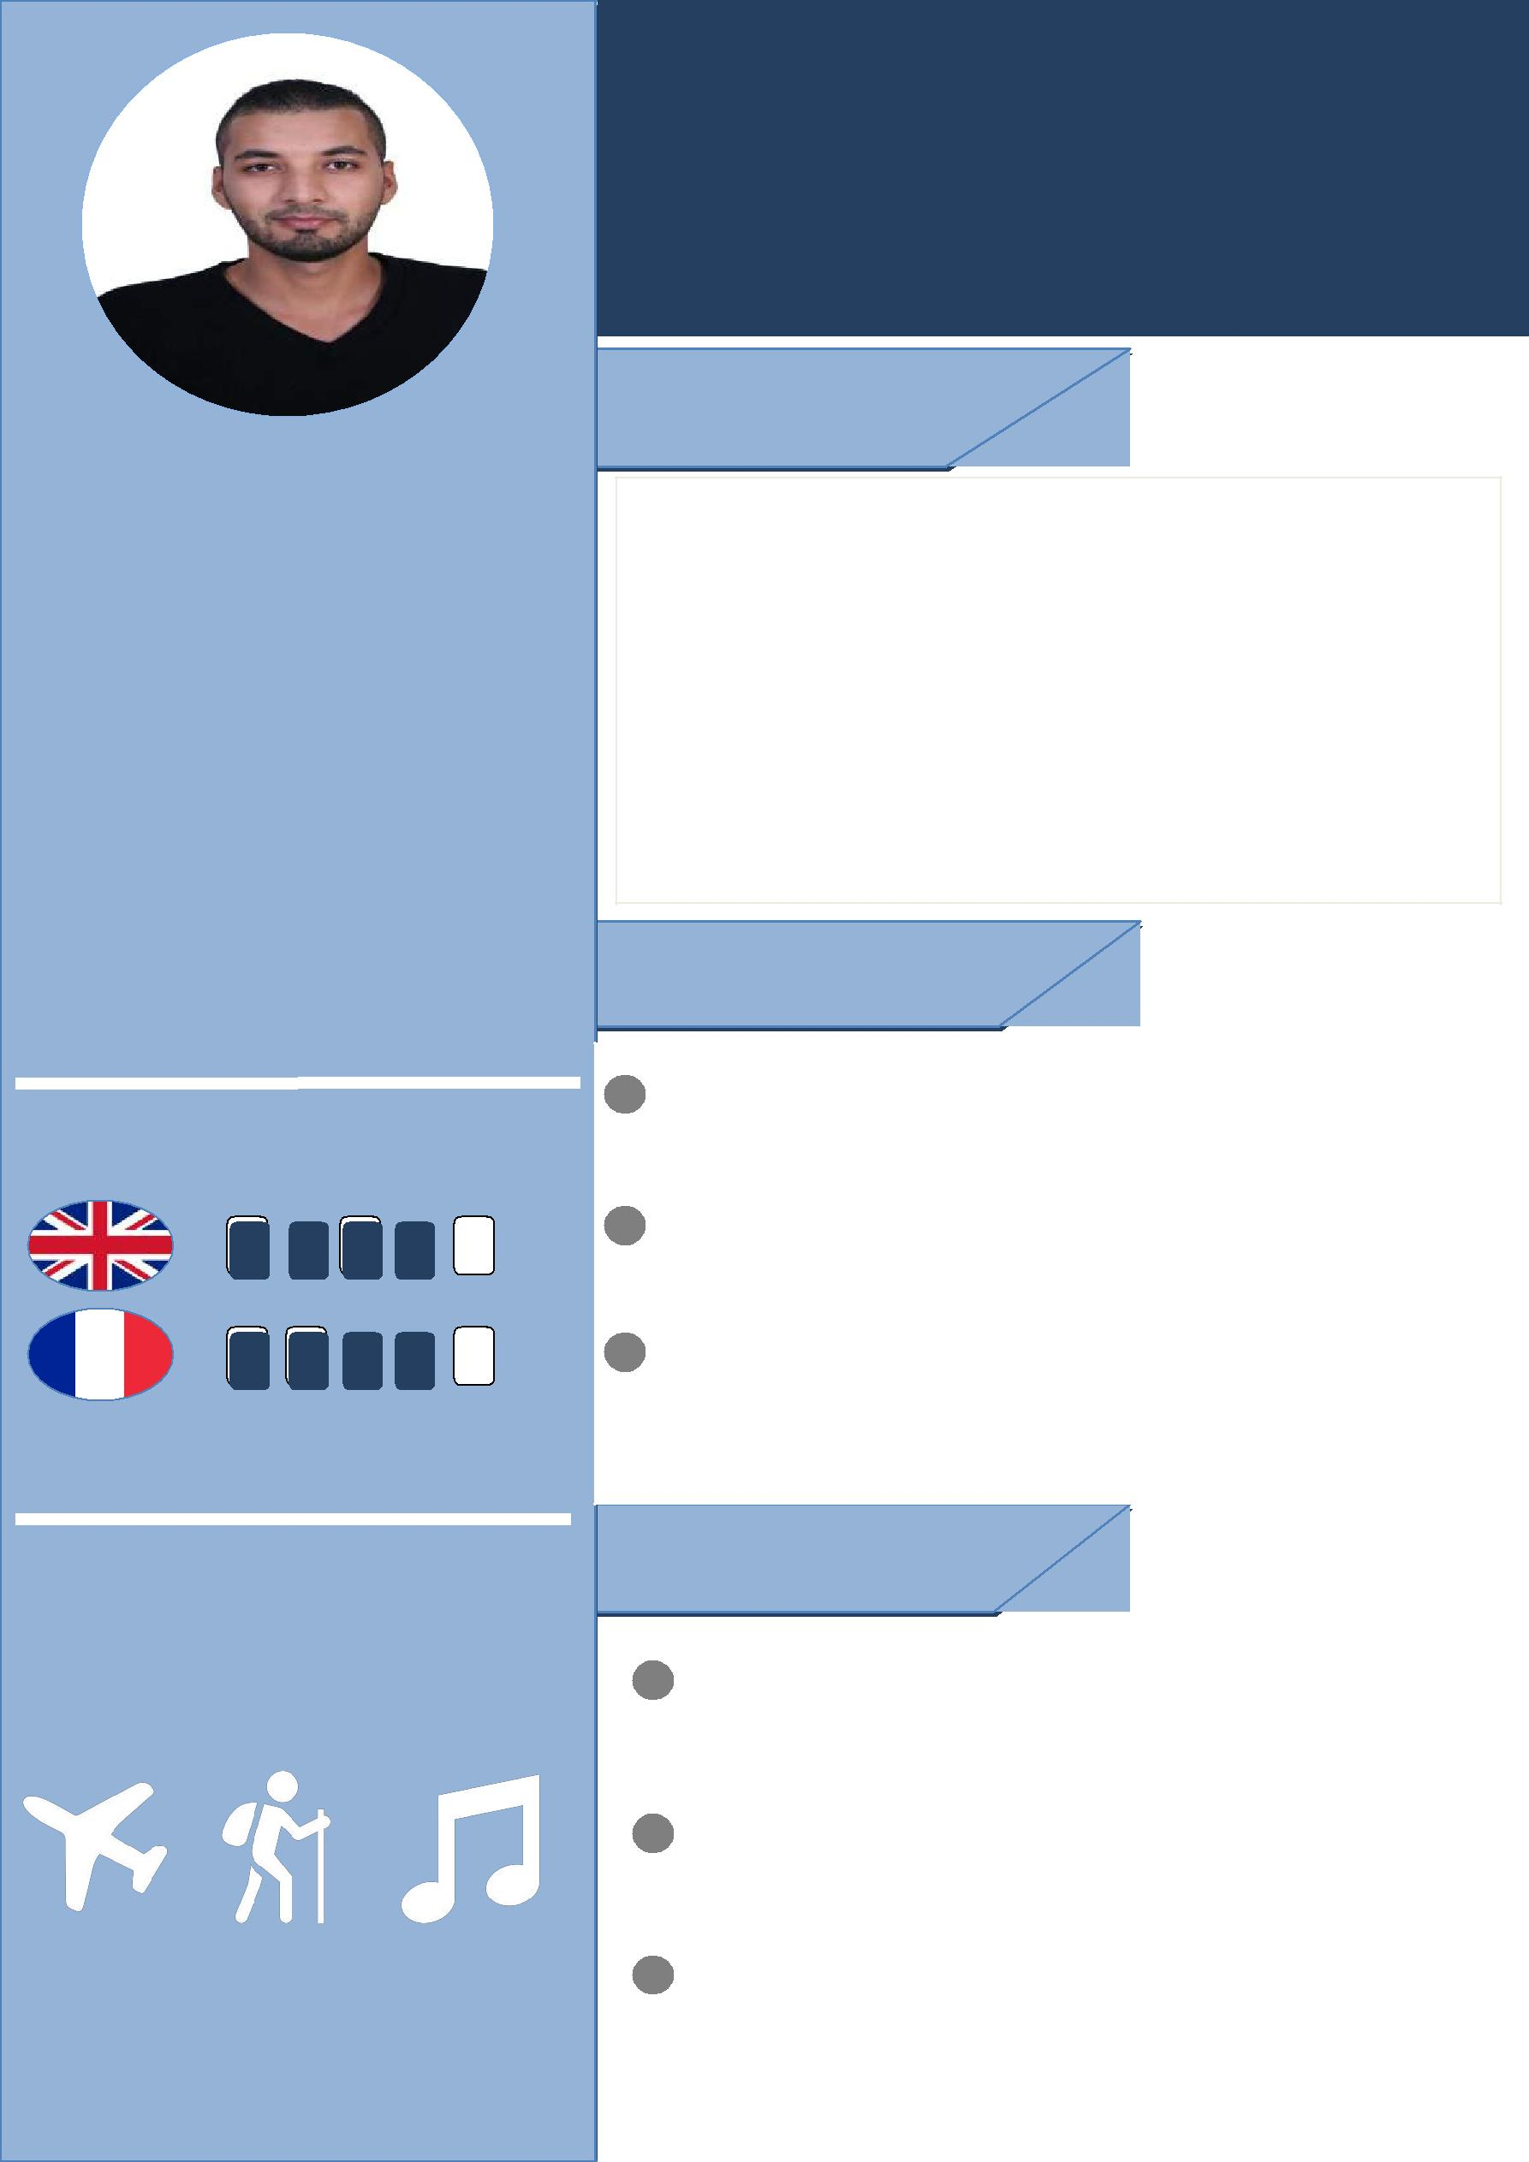

Profile

Younes, 24 years old, single Received a master's degree In History and Geography with a very good grade.

And a certificate of composition in the electronic media.

My confidence in myself is my strength and my ability to communicate with people allowed me to do my job successfully
.

Education

²⁰⁰⁹ ⁻ ²⁰¹² Bachelor of Arts and Philosophy
High School Bekay Abedalleh

^{2012 – 2017} Master of History and Geography University Abu bekr belkaid

²⁰¹⁵ – ²⁰¹⁶ certificate of composition in the electronic media

Professional formation center Ghazouet

Experience

Agency travel "asmahan tour " 2016/2015 Receptionist - Tlemcen

Boudjnan Hamza Primary School 2016/2017
Teacher – Souahlia

I work in restaurants and cafes

