**http://www.egyrec.com/images/Curriculumvitae.gif**

**Personal Information:**

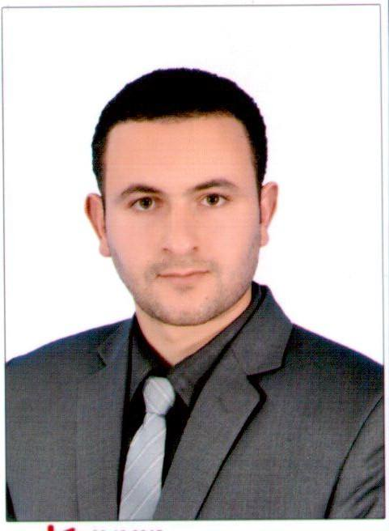**Name: Mohamed**

**Date of birth: 11/04/1992**

**Place of birth:**  **Egypt**

**Gender: Male**

**Nationality: Egyptian**

**Marital Status: Single**

**Tel No.**  **+971504753686 / +919979971283**

**E-mail:**  [mohamed.376318@2freemail.com](mailto:mohamed.376318@2freemail.com)

**Education:**

|  |
| --- |
| * ***Qualification* :** B. SC. In Civil Engineering Mansoura university * ***Grade* :** Good * ***Graduation*:** 2014 |

**PROFESSIONAL COURSES**

**:**

1 - Professional Engineering Site’s Diploma from Cambridge International College (Certificate serial Number: CIC1511643 ) .

2-Autodesk Revit Structure BIM (Modeling + shop drawing + scheduling)

3-AUTOCAD 2D.

4- Make Requst for information (RFI).

5-Sap & Safe Design.

6-ICDL (Certificate serial Number: EGY000926820).

7-Navisworks BIM .

8- I have KSA DRIVING LICENSE

|  |  |  |  |
| --- | --- | --- | --- |
| **As** | **In** | **To** | **From** |
| Technical Office Engineer and the work of design necessary and full supervision of the concrete works and final finishes | AL hejer for Constructions in KSA | 10/2017 | 8/ 2016 |
| Work as a technical office engineer ; receiving and handing over works and work of the owner and contractor extracts | Arabian company in egypt | 5/2016 | 2015 |
| Design and modeling by Revit ; sab and E-TAB | SBS Office | 2015 | 2014 |
| Training Site | Educational Buildings Authority in egypt | 2014 | 2012 |

**Practical experience:**

**:**

**Languages:**

**:**

* Arabic : Mother Tongue.
* English : Good Spoken And Written.

**Special Skills:**

* **Excellent communication skills.**
* **Ability to work under pressure.**
* **Able to learn new tasks quickly.**
* **Self-motivated, dependable.**
* **Ability to work individually and as cooperative team member.**