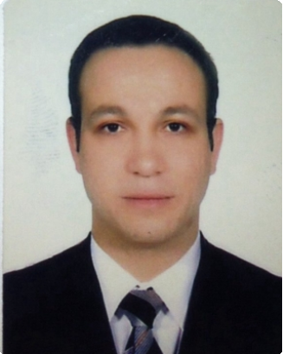
Samer

E-mail :
Samer.376322@2freemail.com

Phone :
+971504753686 /
+919979971283

Birthdate:

23-10-1982

Work experience

BA workshop February 2016 — Present
Workshop manager

Performs trouble shooting and diagnostics procedure on vehicles and equipment.
Record observations and findings during diagnostics run and decide on the correct method of repair, as necessary. Ensure that warranties are properly followed up, monitored, and documented.
Hands-on supervision of all workshop activities, especially technical issues. Supervise and follow up on actual progress of each individual repair job.
Provide on-the-job training as well as coaching and mentoring to mechanics and helpers.
Follow up repair order, registering the time taken to complete each task

Alsarh August 2014 — December 2015
plant manager

1. Responsible for carrying out warranty repairs to manufacturers guidelines. Including repairs, replacing brakes and suspensions, servicing of vehicles. Also ensuring all work is completed on time & within service schedules.
2. Duties:

Calculating & verifying the estimated parts required for repair. Repairing and servicing vehicles booked into the workshop. Carrying out test drives on vehicles to diagnose existing faults.
Investigation faults using special mechanical tools and diagnostic equipment
Ordering or picking up parts from suppliers.
Checking every critical part of a vehicle, including belts, hoses, plugs, and brake and fuel systems

NCC February 2013 — July 2014
mechanical engineer

Diagnose cause of any malfunction and perform repair Communicate with parts department to obtain needed parts. Review and report an all malfunctioning vehicles, tractors, buses and trucks
Review and approve all purchases of fuel, spare parts, and vehicles and equipment’s
Ensure that all vehicles are in good condition
Provide suggestions on how fuel and maintenance expenses can be cut down
Assist in reaching error codes in the relevant catalogues and systems understand and apply the technical use of various tools and equipment
Examine the vehicle to determine if additional safety or service work is required
Review the reports generated by the auto diagnostic scanner and ensure that problems identified are properly resolved
Training Course

Student’s Training14 Weeks

L’viv polytechnic national university-Ukraine .

·Summer 2009-2010- 2011: Summary: Training at the artistically workshop for the big mechanisms. Diagnose and repair various automotive systems (brakes and hydraulic, exhaust, advanced fuel ignition and electrical

·July-August 2012: NEW COMPANY FOR TRADING&CONTRACTING working as a mechanical engineer.

·Master’s Training (in the university laboratory)

Education

Master in mechanical engineering and transport (automobiles and automobile supply)
L’viv polytechnic national university-Ukraine.
September 2011 — December 2012

Bachelor in mechanical engineering and transport
L’viv polytechnic national university-Ukraine.
September 2007 — June 2011

Languages Arabic, English, France, Ukraine.

Computer Skills / Key Skills and Competencies

·All kinds of Windows Offices (Word, Excel, Power point, Access, Front page)

Aware of safety regulations when lifting heavy tools and parts.
Experience of servicing large vehicles such as trucks 7.5 tone lorries & above. Ability to identify & diagnose vehicle faults. Experience & knowledge of the latest IT technologies used in fault diagnosis. Experience of mechanical work at a car dealer franchises and auto supply store

Others / Hobbies

·Available to Work in/out office for long time and under pressure.

·Available to new work experience abroad.

·Available work with team.

-Ability to learn new concepts, theories and technologies

-Competent in problem solving

-Proactive and self-motivated

Billiard -football

