RESUME
Abdul
Seeking a challenging position in Civil engineering which would enables me to utilize my knowledge and hard work in growth oriented organization.

CAREER OBJECTIVE
To work in a responsible position within a reputed organization which will provide me an opportunity to deploy my strength and skills , at the same time, provide me with the exposure to enhance my knowledge and capabilities.

JOB EXPERIENCE

PA Hameed Designation: Site Engineer cum Draughtsman

Associates (from JAN 2017 to NOV 2017, PART TIME)
Job Responsibilities :
- Site inspection for civil construction work and ensure that the work is as per the project specifications and issued for construction drawings/ final approved drawings from authorities.
- Proper management of materials and workmanship.

Ensure that all the works meets the stipulated quality standards.

Responsible for the Architectural &amp; Structural drawings for Low rise and High rise Residential and commercial buildings.

Preparing Plans, Sectional details & Elevations Using Revit & AutCad

EDUCATION
2013 - 2017 B.E in CIVIL ENGINEERING
P A COLLEGE OF ENGINEERING ,MANGALORE, INDIA

2011 - 2013 HIGHER SECONDARY COURSE [CS]
KERALA EDUCATION BOARD

CERTIFICATION

2017 AutoCAD 2D, REVIT architecture & ETAABS
KASARAGOD , INDIA

OPERATING SYSTEMS
MS Windows XP/Vista/7/10.

MS OFFICE:
MS Word, Excel, Power Point

SOFTWARE:
AutoCAD, REVIT ,ETAABS
Internet browsing and email management

PROJECT WORK

DESIGN OF UNDER GROUND RECTANGULAR WATER TANK USING STAAD PRO.

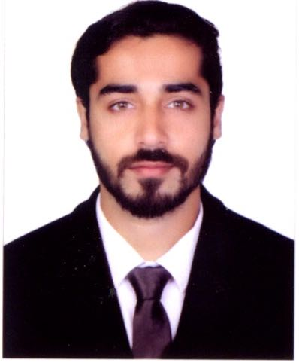

CONTACT DETAILS

Mobile : +971504753686 / +919979971283
Email: Abdul.376329@2freemail.com

PERSONAL SKILL
Motivating people Personal Management Leadership
Strong Work Ethic Flexibility and Adaptability
Communication Skills

LANGUAGES
ENGLISH HINDI MALAYALAM

PERSONAL DETAILS
Nationality
INDIAN

Marital status
SINGLE

Religion
ISLAM

Date Of Birth
27th April 1993

Visa Status
VISIT
(EXPIRES BY MARCH 2nd 2018)

