CURRICULUM VITAE
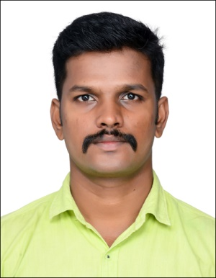

Nijo

SHARJAH
(on Visit Visa upto Feb 12 2018)
Mob. Ph : Whatsapp +971504753686 / +919979971283
Email: nijo.376330@2freemail.com
CAREER OBJECTIVE

To be an active learner, creator and enabler to reach greater heights in the field in which I work and to acquire high academic qualification by continuous learning. To be the best and do the best to the concern I am working for. To give my active participation and effort for the growth of the company.
ACADEMIC DETAILS

COURSE | DISCIPLINE/ SPECIALISATION | SCHOOL/COLLEGE | YEAR OF PASSING | Marks
DIPLOMA (equal to Degree) | Diploma in electrical & electronics engineering | Thiagarajar Polytechnic College Alagappanagar | 2013 | 84%
12th Secondary School | Maths,Physics,Chemistry,Biology Sci. | G.H.S.S Kodakara | 2010 | 73%
School | SSLC | Sree Krishna High School Ananadapuram | 2008 | 93%

PROFESSIONAL TRAINING AND QUALIFICATIONS

- NEBOSH - 00354505/847730
- IOSH certified. Certificate no : 480653
- MEDIC FIRST AID certified Certificate no : 1987743
- SCAFFOLDING INSPECTOR certified Certificate no : STI 48407

PROFESSIONAL EXPERIENCE

*2014 JANUARY –2015 JAN :
TECHNICAL APPRENTICE in KELTRON
*2015 MAR – 2017 JULY :
SAFETY SUPERVISOR in SUROJ BUILDCON PVT LTD
Key Skills & Job Responsibilities

*Monitoring and Assessing hazardous and unsafe situations.
* Implementation of the HSE policy.
* Prepare HSE reports and Documents
*Take apart in Site safety Inspections,Internal Audits and conducts Toolbox meetings ,Training.
*Enforces Safety Guidelines & performs emergency Response Drills.
SOFTWARE SKILLS

- AutoCAD , Electrical CAD
- Revit MEP 2014
- Microsoft Office Tools
STRENGTHS

- Positive Attitude.
- Hardworking, Dedication & Determination.
- Establishing good working relationship with others.
PERSONAL DETAILS

Marital Status : Single
Date of birth : 10 Mar 1993
Nationality : Indian
Languages known : English, Malayalam, Hindi, Tamil.
Visa Status : visit visa 17/11/2017 – 12/02/2018

DECLARATION:

I assure you sir, if given an opportunity to serve your esteemed organization, I will discharge my duties to the entire satisfaction of my superiors and would strive maximum to help achieve the assigned target.

I hereby declare that the information furnished above is true to the best of my knowledge.

NIJO

