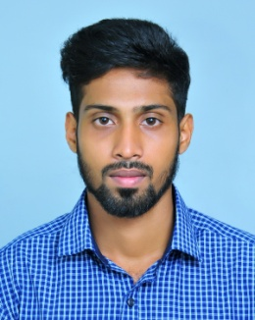

JOSEPH

Dubai

Mob: +971504753686 / +919979971283

Email: joseph.376343@2freemail.com

OBJECTIVE

To pursue highly challenging career in the field of Accounts, Audit and Finance where I would apply my knowledge , experience and ideas to develop high caliber professional skill and effective management technique by proactive research and development activities to ensure protection of interest of industry and emerge as a good corporate professional

Profile

- Bachelor of Commerce (B.Com) from Mahatma Gandhi University.
- Able to do computerised accounting and preparing financial statements of different business organizations.
- Acquired hands on experience in income tax audits, audits as per companies act and procedure for maintaining ledger and day books .
- Abilities in preparation of Audit reports.

EDUCATIONAL QUALIFICATION

Degree Board/University Year

- B. Com Mahatma Gandhi University, Kerala 2014
- 12th Board of H.S. Education, Kerala 2011
- 10th Board of Secondary Education, Kerala 2009

PERSONALITY & STRENGTHS

- Ability to work in a fast-paced Environment
- An effective communicate with good analytical, negotiation & co-ordination skills.
- Self-Motivated and ability to take initiative.
- Strong Administration skills
- Creative problem solver
- Excellent time management skills
- Able to handle multiple tasks

WORK EXPERIENCE

- Worked as accounting and auditing staff under C.A N.Sudarsanan& Com. (Chartered Accountant) for a period of 2.1 years from 5th October 2015 to 23rd November 2017.

AREA OF INTEREST

- Accounts, SalesSupervisor, Admin &HR Assistant

KEY SKILLS

- Good accounting knowledge
- Overall office administration
- Accounts and Document Control
- Customer relationship
- Inventory & Store management

COMPUTER SOFTWARE SKILLS

- MS Office packages (Excel, word and Power point)
- Tally 7.2 , 9 and ERP 9

PERSONAL PROFILE

Nationality : Indian
Date of birth : 20-12-1993.
Sex : Male
Marital Status : Single
Visa Status : Visiting Visa (Valid up to 28-3-2018)
Language known: English,Malayalam and Tamil.

DECLARATION

I hereby declare that the above information are true and correct as per my knowledge

Dubai JOSEPH

