CURRICULAM VITAE

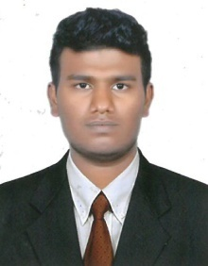
HASEEB
Abu dhabi(U.A.E)
Mob : +971504753686 / +919979971283
E-mail: Haseeb.376345@2freemail.com

Career Objectives

Work Experience :
Aiming for an innovative, challenging, responsible and regarding career where there is a scope for upgrading knowledge and where I can take part in the growth of the organization.

- Emic & MIW Technologies Calicut India
(April 2013 to July 2015).
- Snow Bell security System Al Qunfudhah Saudi Arabia (May 2016 to August 2017).

- System Administration
- Networking devices configurations
- Computer Hardware Software Support
- Laptop & Desktop Technical Support
- Networking Essentials
- Operating System
- IP camera Configuration
- PTZ Camera Configuration
- Access Control System
- Video Door phone
- Troubleshooting
- Structure of cabling

Academic profile

Courses | Year of Study | Board / University
Degree(BBA) | 2011-2014 | Periyar University Salem
Plus Two | 2008-2010 | HSE (Govt. of Kerala)
S.S.L.C | 2007-2008 | Board of secondary education(Govt. of Kerala)

Courses | Year of Study | Board / University
CCN (Certificate in computer networking) | 2011 | Lakhotia Computer Centre
Computer Hardware | 2012 | Jetking Bangalore
CNA (Cisco network administration) | 2014 | Accel IT Academy Calicut
CCTV (Certified security systems technician) | 2015 | IT Academy Malappuram
Professional Qualification

Personal Details

Date of birth : 1992-10-05
visa status : transferable visiting visa (valid 03/01/2018)
Nationality : Indian
Religion : Islam
Marital status : Single
Language known : English Arabic Hindi and Malayalam
Hobbies : Travelling, Photography, Driving
Strength : Self confidence, Coordination ability, diligence at work,
optimistic, willingness to learn, team facilitator, Punctuality
and Event Management.

Declaration

I hereby declare that all the information given is true to the best of my knowledge.

Haseeb

