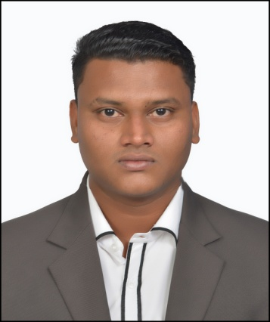

CAREER OBJECTIVE

Seeking a deserving profile as a hospitality student in a dynamic organization where I can achieve my goals as well as organizational goals with the help of my hospitality skills and my work ethics thereby maintaining the reputation of my organization.

PERSONAL DETAILS

NAME Andrew

DATE OF BIRTH 19th October 1996

EMAIL ID: andrew.376377@2freemail.com

MARITAL SATUS: Unmarried

LANGUAGES KNOWN: English, Konkani and Hindi

EDUCATION QUALIFICATIONS:
QUALIFICATION | MONTH AND YEAR OF PASSING | NAME OF THE INSTITUTION | GRADE | BOARD
DIPLOMA IN HOTEL MANAGEMENT AND CATERING TECHNOLOGY  ( 3 Years) | June 2017 | Agnel Institute of Food Crafts and Culinary Sciences, Verna- Goa. | DISTINCTION | AICTE  New  Delhi  &  Goa Board of Technical Education
H.S.S.C  (ARTS) | March 2014 | M.E.S Higher Secondary School,  Zuarinagar- Goa | SECOND | Goa
S.S.C | March 2012 | Deepvihar High School,  Headland Sada- Goa | SECOND | Goa

WORK EXPERIENCE:

NAME OF THE HOTEL | DEPARTMENT | DURATION
The HQ, Hotel  Vasco-da-Gama | Food and Beverage  (Service) | 4 months & 15 days
Planet Hollywood Beach Resort, Utorda. | All Departments | 5 months
Park Hyatt  Resort and Spa, Utorda. | Front Office | 20 days

ACHIVEMENTS:

- Awarded ‘The Best Student – in Housekeeping Department for the Academic Year 2016-17’ by Agnel Institute of Food Crafts and Culinary Sciences, Verna- Goa.

- Awarded ‘The Best Trainee of the Month’, during Industrial Training at Planet Hollywood Beach Resort, Utorda - Goa.

- Awarded a WOW CERTIFICATE, by Planet Hollywood Beach Resort, Utorda, for outstanding ‘RED CARPET SERVICE EXPERIENCE’, during Industrial Training at Planet Hollywood Beach Resort, Utorda - Goa.

DECLARATION:
I hereby declare that all the information given above is correct to the best of my knowledge and belief.

Yours sincerely,

(Andrew)

(Andrew)

