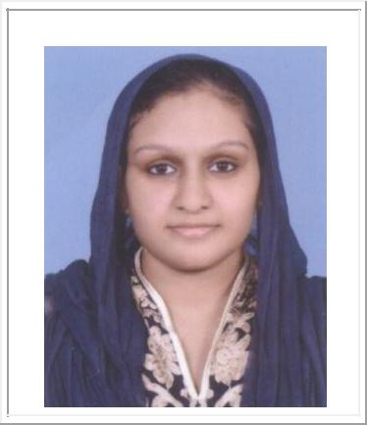

Ruxana

Email: ruxana.376384@2freemail.com

Objective

To be a part of a dynamic and challenging organization that offers attractive growth opportunities where I could apply my knowledge and enhance my capabilities and skills for contributing to the growth of the organization.

Professional Experience

Worked as Executive – Admin and HR from August 30, 2013 – September 01, 2015 with Reynex Software Private Limited, Technopark, Thiruvananthapuram.

- Co-ordinating with candidates for interview & conducting telephonic interview before short listing candidates.

- Providing complete, accurate, and inspiring information to candidates about the company and position.

- Arranging for personal interview on short listing, having good co-ordination with the candidate arranging the final interview.

- Co-ordinating with the company and with candidates after company selects the candidate.

- Maintaining daily/weekly/monthly reports such as interview status reports, closure reports & feedback reports.

- Conducting induction for new joiners.

Personal Skills

- Able to analyze and solve problems
- Attention to details
- Quick learner and well organized

- Efficient in communicating well in written and verbal both.
- Ability to prioritize and remain focused on the essence of an issue.

1

Academic Qualification

- B.Tech (Biotechnology & Biochemical Engineering) [University of Kerala]
  - Mohandas College of Engineering & Technology, Trivandrum, Kerala, India (2006-2010)

- 12th [CBSE]
  - New Indian Model School, Dubai, UAE (2006)

- 10th [Kerala State Board]
  - New Indian Model School, Sharjah, UAE (2004)

Computer Knowledge

- Internet
- MS Office: Word, Power Point & Excel
- E-Mailing tools: MS Outlook, Yahoo and Google

Academic Projects:

- Centre for Bioinformatics, Karyavattom Campus, Trivandrum
Project on Protein Structure Prediction of Human HCV-Ns3 Protein using Homology q2qModelling

- Travancore Titanium Products Limited, Trivandrum Industrial Training

Personal Details

DOB | : | March 09, 1989
Gender | : | Female
Marital Status | : | Married
Nationality | : | Indian
Languages Known | : | English, Malayalam and Hindi
Visa Status | : | On Visit

Declaration

I hereby declare that all the information mentioned above is true to best of my knowledge.

2

