Career Objective

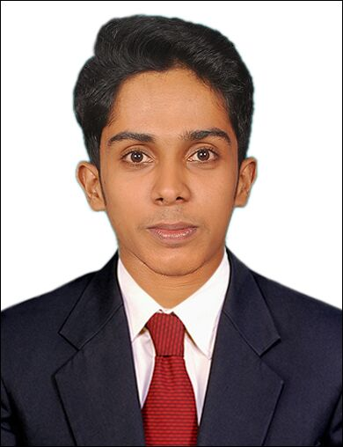

VYSAKH

EMAIL:
Vysakh.376408@2freemail.com

Home phone :
+971504753686 / +919979971283

Sex : Male
Nationality : Indian
Marital Status : single
Date of Issue : 10.07.2015
Date of expire :09.07.2025

Electrical Engineer with 3 year of experience working with Reliance J3 Project Jamnagar. Primarily focus on implementation of electrical system. Excellent interpersonal and communication abilities, and possess a wide range of technical skills. Enjoys being part of team , as well as managing and motivate in high pressure and challenging work environments.

Professional experience

ELECTRICAL SUPERVISOR From 08.09.2014 to 30.08.2017
Construction of Refinery at Reliance industries Limited J-3 Projects.At+PO-Motikhavadi,dist-Jamanagar, gujarat ,PIN-361140
Name and address of contractor
: L&T HYDROCARBONS ENGINEERING LIMITED. RIL,J-3 project ,
jamanagar (Gujrat)361140
Name and address of Establishment under which contract is carried on

: DELTA CONSTRUCTION
RIL,J-3 project , Jamanagar (Gujrat)361140

Work responsibilities
- Plan and work schedule projects, estimate time and materials,
supervise subordinates, maintain records and files and prepare
reports.
- Plan and supervise work of electricians.
- .Maintain records on electrical jobs and assign to appropriate
personnel.
- Advice coordinator and assistant director of technical problems
concerned with insulation, modification and repair of electrical
assignments.
- Conducting daily safety / Toolbox Meetings for Technicians.
- Work Procedure.
- Site inspection and Supervisions to make sure the work progress
- Industrial lighting
- Cable laying, Glanding and Termination up to 500 Sq.mm.
- Conduit laying and wiring.
- Schedule the job and completion as per the targets within the estimated cost /
agreed time schedule.
- Responsible for ensuring safety requirements are followed at site as per
Company safety management system manual.

Academic background

- Anna University-RVS College of engineering and technology –
BE(Electrical and Electronics Engineering )
- Plus two-Sreekrishna higher secondary school Guruvayoor-Biology
Science
- SSLC-St Francis higher secondary school,Mattom
Strengths
- Expertise in coordinating and supervising activities.
- Enjoy working in a fast-paced environment; highly detail-oriented.
- Friendly team player with professional manner .Self motivated

Project done

PORTABLE WIRELESS BIOMEDICAL HEALTH MONITORING SYSTEM

- This project describes a design for smart device
- Device that aim to determine the human heart beat rate ,temperature rate and respiration rate of body
- The doctor can monitor and diagnose the patient's condition and could suggest earlier prevention measures for the patients themselves via SMS

Personal interests
• Coin collection
• Traveling
• Riding

Declaration

I hereby declare that all the information given above are true and correct to the best of my knowledge
Place :-
Date :-

Area of interest
• Design of circuit
• Electrical -
applications
• Project-
management
• maintenance

Proficiency
• E CADD
• REVIT-MEP
• PRIMAVERA-P6
• MICROSOFT

Languages Known
- English
- Hindi
- Tamil
- Malayalam

