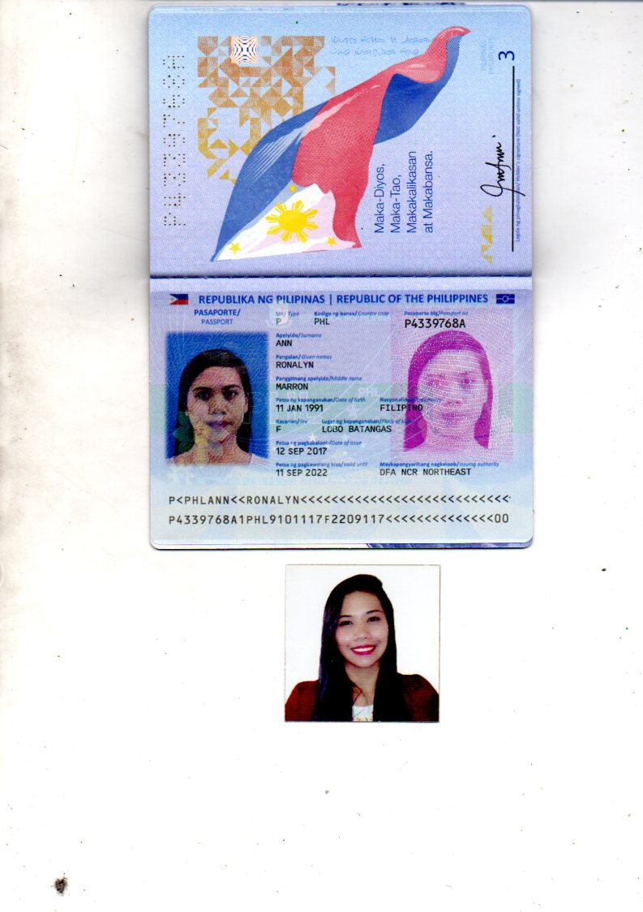

EXPERIENCES:

SKILLS:

CURRICULUM VITAE

DESIRED POSITION:

EDUCATION:

Ronalyn

CURRICULUM VITAE

*Accounting Clerk*

*HR Assistant*

*Office Secretary*

*Office Clerk*

*Receptionist*

*MS Office Applications*

*Internet Literacy*

*Manual Payroll*

*Knowledge in doing remittances*

*Other Office-related Jobs (Filing, Classification)*

*Time Management*

*Work under pressure*

*Communication Skills*

*Willing to be train*

**ACCOUNTING STAFF**

*March 1, 2015 until July 20, 2017.*

*JMS STAFFING SOLUTIONS, INC.*

*Suite 210 St. Anthony Bldg, 891 Aurora Blvd., Cubao, Quezon City*

**ACCOUNTING STAFF**

*October 17, 2012 until February 28, 2015.*

*Jobline Manpower Services*

*Suite 210 St. Anthony Bldg, 891 Aurora Blvd., Cubao, Quezon City*

**BACHELOR OF SCIENCE IN INFORMATION TECHNOLOGY**

*Samson College of Science and Technology*

*Cubao, Quezon City*

*June 2007 until March 2011*

**Mobile:**

*+971504753686 / +919979971283*

**Email:**

[*Ronalyn.376410@2freemail.com*](mailto:Ronalyn.376410@2freemail.com)

**Date of Birth:**

*January 11, 1991*

**Nationality:**

*Filipino*

**Status:**

*Single*

**Languages:**

*English*

*Tagalog*