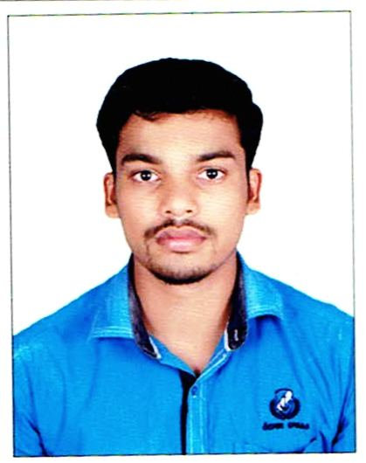
RESUME
SATHISH
Email: sathish.376449@2freemail.com
Mobile: C/o 971501685421
Visa status: Visit visa
Visa exp date: 26/02/2018
Current location: Al Ain, U.A.E

Objectives

To learn a Professional career, utilizing my skills and learn continuously for the betterment of my capabilities and hence contributing to the development of the Organization.
Industrial Experience

Company Name : Sangsin Brake India pvt Ltd
Department : Production
Designation : Team Member (Electrical & Electronics Eng)
Period : April 2015 to April 2017
Responsibilities:

- Machine loading plan, Tools planning, Manpower planning
- Upgrading 5s at shop floor
- Prepare & Maintain work Instruction & Route card
- Poke yoke, Kaizen development
- FIFO System maintain at shop floor
- Implementation of developments to improve the productivity
- Study & analyze about existing machine capacity & their improvements.
- Customer audit document preparation
- To implement Lean manufacturing
- Development work to upgrade the Productivity.
- Maintain ISO & TS16949 documents
- Responsible for servicing and maintenance of equipment.
- Propose modifications and retesting the products
- Monitoring products in use to improve on future design
- Keeping in line with the latest developments and technology

Industrial Experience:
Company Name : ELMEC HEATERS & CONTROLLERS
Designation : Diploma Trainee
Period : 2013 Aug to 2014 Nov.
Responsibilities:
- Allocating load arrangements to machines & Men.
- Coordinate with technicians and provide support to all teams and maintain quality of all work processes in systems.
- Development work to upgrade the Productivity
Education
- Diploma in Engineering (DEEE) in ELECTRICAL &ELECTRONICS ENG from muthayammal polytechnic institution –Rasipuram Tamilnadu (2011-13)(over all % 96.8)
- SSLC -Govt Higher secondary school, tho. jedar palayam. (2009)(over all% 59)

Computer skills:
Operating Systems : Windows 7&8.1
Package : MS Office, Auto CAD, c, c+

Personal details:

DOB : 15.11.1994
Gender : Male
Marital Status : Single
Languages Known : Tamil, English
Declaration

I hereby declare that the above given information are all true to the best of my knowledge.

Yours Faithfully,
(Sathish)

