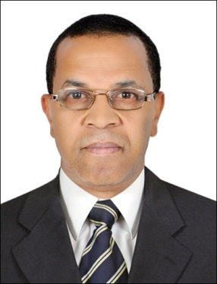 CURRICULUM VITAE

RHANNAMI

Mobile: C/o 971503718643

Email: rhannami.376459@2freemail.com

SUB : BANQUET Supervisor / assistant banquet manager

Career Objective:

Seeking a permanent position as a banquet supervisor & catering Supervisor to fully exercise my skills, abilities and contribute positively to the company according to my 12years experience ,
Personal Profile:

Name : rhannami

Date of Birth : 06/06/60

Religion : Muslim

Nationality : morroco
Marital Status : Single

Languages Known : Speaking French/ English / arabic

Hobbies : Reading Books, like Football,

Personal Traits : Honest, Sincere, Systematic approach to work & Teamwork

Educational qualifications:

- Baccalaureat +2 years

- 2 years in university Mohamed Ben Abdullah (French linguist )

Professional Experience:

>2009 to 2017

Incharge for wedding hall Al Shahama :

Position :camp manager /store control
Company National Corporation for Tourism & Hotels
Place Abu Dhabi.(Location EMICO.
Period from 26th November 2009 to 7th August 2011

BANQUET SUPERVISOR:

In charge for wedding hall ( set up. Breaffing the staff and schedule
In charge for the events inside and outside the hall
In charge for the staff housekeeping and restaurant

Position: campmanager G/S CAMP KOREAN –RUWAIS/ ENEC- SILA-
Company ROYAL CATERING
Place ABU DHABI –UAE-
Period 7th May 2011 to 3rd October 20 13

Position Held BANQUET SUPERVISOR
catering ROYAL CATERING
Place ABU DHABI, UAE
Period 21st 2013 UP TO2017

Position : supervisor:

Zohara hotel ( meknes / morrroco)
Supervising the staff and monitoring the
The operation ( check in check out)
Period :
From: 1996 to 1998

Brief Summary of Strengths & Duties:

- To organize, direct and support employees & provide maintenance operations to obtain the highest standard and also to provide efficient, courteous and trouble-free service to the customers.
- Knowledge of Machine operation , and inventory control
- To train the team for proper utilization of chemicals for cleaning and utilization of other equipments & materials.
- To mentor team members of about 25 and maintain discipline

- Effectively handling of customer’s complaint and to solve it with satisfactory solutions.
- Able to meet deadline.
- Can perform multitask and work under pressure if required.
- Can deal with any sudden responsibilities and duties if arisen.
- Perform random inspection of the rooms and public areas and follow ups where necessary
- To assure all maintenance requests forwarded to engineering are executed
- Report any shortages in equipment to the manager
To communicate & co-ordinate with all departments and guarantee the highest level of guest

- satisfaction
- To update record in the comput

Extra Curricular Activities:

CERTIFICAT: * FOOD HYGIENE /HANDLING HELDAT(BAB)
ABU DHABI COMPANY FOR ONSHOREOIL OPERATIONS (ADCO)
* Elementary food hygiene certificate (Royal Enviromental health
Institute of Scotland
- Training certificate of :
- -basic food safetyrequirements
- - kitchen & personnel hygienepractices
- - HACCP Awareness
- - food hygiene conductedby TUV MIDDDLEEast
- Computer- excel

