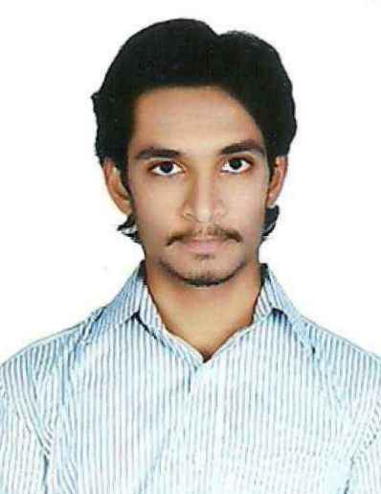
CURRICULUM VITAE
Ferhan (HVACENGINEER)
C/o-Mobile no: +971-501685421 Email:rasool.376460@2freemail.com

Career Objective:
Seeking a challenging role as a HVAC Engineer where I can utilize my knowledge and skills in best possible way for the fulfillment of organizational role.
Professional Experience:
- Worked as Hvac Engineer in Najranin Saudi Arabiafrom 10/2014 to 09/2016.
- HVAC Site engineer in Hyderabad from 10/2016
Roles and Responsibilities:
- Preparing the HVAC system shop drawing as ASHRAE and local Authority standard and obtain the consultant approval
- Preparing the material submittal as per the Contract documents and obtain consultant approval
- Coordinate with other MEP services and prepare Coordination drawing, builders work drawing and Reflect ceiling plan drawing.
- Preparing the bill of materials.
- To manage the man power and distribute the work accordingly to complete the projects in stipulated time.
- Check and inspect the installation of Air-conditioning system as per the approved shop drawings and obtain the consultant Engineer approval.
- Ensure safe work environments, control the use of materials and avoid damages and waste, request material, tools and equipment needed for the project.
- Reporting the progress on the site through documentation and by taking on site photographs
- Ensure smooth commissioning of the erected HVAC system.

Academic background:
- B. Tech (Mechanical Engineering) from G.Pulla Reddy Engineering College, Kurnool, affiliated to JNTU Anantapur during the period 2010-2014.
- Intermediate (MPC) from Narayana Junior College, Kurnool, affiliated to Board of Intermediate Education during the period 2008-2010.
- SSC from Sister Stanislas Memorial English School, Kurnool, affiliated to Board of Secondary Education.
Certification courses:
- HVAC Designing and Drafting at Dhanush Engg Services India Pvt. Ltd., Hyderabad for 45 days.
- Trained in Solid Works and Unigraphics.
Project works:
Project name: Aurobindo Pharma(Units 1 and 9)
System: Carrier ductable split units
Capacity : 100 TR
Consultant: Comfortline Aircon
Academic project:
Title: Manufacturing, analysis and assembly of component Milling Sleeve for Horizontal Milling Sleeve.
Duration: 3 months(Internship in HMT Hyderabad)

Softwares known:
- Auto Cad
- E-20 form ( heat load calculations )
- Mc-Quay duct sizer
- M.S Office

Personality traits:
- Punctuality
- Good team player
- Adaptability
- Quick learner.

Personal details:
- Date of birth: 04-03-1993
- Languages known:Arabic, English, Hindi, Telugu, Urdu
- Have GCC (Saudi Arabia) driving license

References will be provided on request

