ABDEL
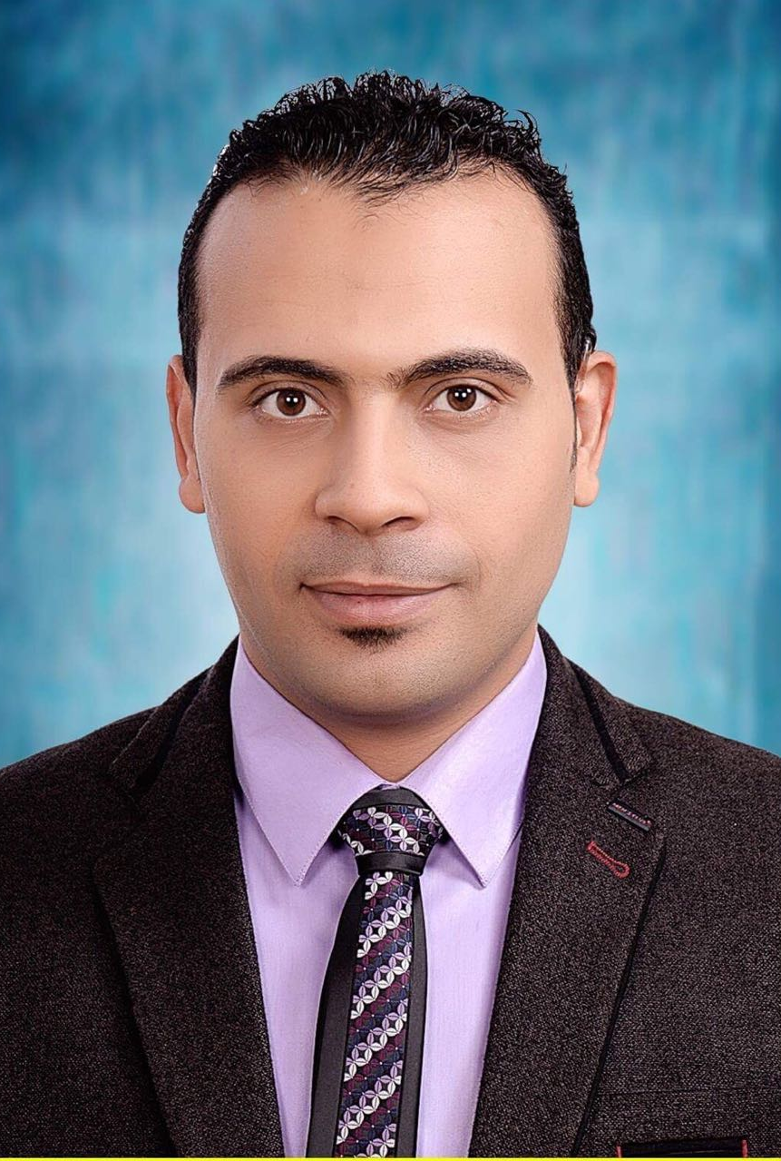

Nationality: Egyptian
Marital status: Single
C/o-Mob: +971504973598
Email: abdel.3764920@2freemail.com
DOB:24/4/1988
Visit visa

OBJECTIVE

Desire a position as Accountant. Offering a progressive accountant experience and customer oriented approach to manage the company’s customers and ensure recurring business. Looking forward to make a significant contribution in an ambitious and exciting company that offers a genuine opportunity for progression.

EDUCATION
Bachelor of Accountant. Year 2014
(Computer of Training and Information Technology Center)inEgypt
Bachelor of Science in Commerce. Year 2010
(Tanta University)

EXPERIENCE

Accountant|
Eweida Electrical Appliances EST2015-2017

Recording data in journal and ledger book by MS Excel
Preparing trail balance
Preparing income statement and balance sheet
Financial statements analysis
Training on construction accounting.

Accountant|
Delta International for Import &Export 2013-2015

Recording data in journal and ledger book by MS Excel
Preparing trail balance
Preparing income statement and balance sheet
Financial statementsanalysis

Accountant|
Mukhtar Trading2011-2013

Responsible for the introduction of cash flow, banks and cash expenses.
Dealing with purchase invoices, payments and returns to suppliers
Dealing with sales invoices, collections and returns for customers
Print Sales Bills and Receipts.
Print all financial and accounting reports such as audit balance, income statement, cash flow, final budget, movement of funds and banks, reports of employees, reports of suppliers and purchases, client reports and sales

Cashier |
Fathalla market 2010-2011

Dealing with sales invoices, collections and returns for customers
Print Sales Bills and Receipts.

LANGUAGES
Arabic: Mother tongue
English:intermediate

COMPUTER SKILLS
Perfect in
- Microsoft Excel
- MS Word
- Peachtree
- QuickBooks

SKILLS
- Enthusiastic, knowledge-hungry learner, eager to meet challenges and quickly assimilate• new concepts.
- Loyal and dedicated employee with an excellent work record.
- Highly skilled in greeting customers in a polite manner Professional neat appearance
- Team player and Familiar with working under pressure with strong communication and presentation skills.
- Admirable experience to develop key relationships and market products within community organizations.
- Remarkable knowledge of sales procedures.
- Outstanding ability to convince customers to buy products.
- Ability to present information clearly and concisely.
- Profoundly ability to effectively and clearly communicate.
- Ability to handle emotionally escalated calls and situations that require empathetic responses.
- Strong demonstrated ability to market and sell in multi-product environment.

All references are to be available upon request
Thank you for your time.

