CURRICULUM VITAE

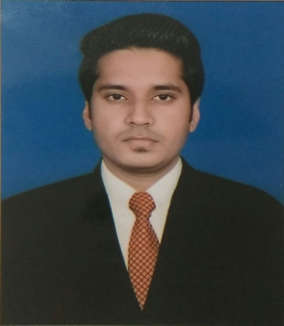
Name: JUNED

Email:- juned.376493@2freemail.com

C/o-Mobile:- +971501685421

CAREER OBJECTIVE

Want to work in an organization where I can keep on upgrading myself and use myself and use my knowledge in betterment and enlistment of an organization.

WORK EXPERIENCE
1 Year experience in Marwal Consultants Company as a Draughtsman(Auto Cad Design)
1 Year 5 Months experience in Alok Maharshi Architects Company as a Draughtsman (Auto Cad Design).

EDUCATIONAL QUALIFICATION

Qualification | School/College | Year | Board/University | division
Secondary | I.R.P.S.S.School | 2008 | Ajmer Board | 2nd
Sr. Secondary | Three Dots Children Academy School | 2010 | Ajmer Board | 1st
B.A. | S.M.L. College | 2015 | Rajasthan University | Pass  (2nd)

ACADEMIC QUALIFICATIONS

- Graphic Design: - Arena Animation (6 Months)
- Photoshop, Coral Draw, illustrator, InDesign, (Sketching).
- Diploma in Interior & Architecture, 2015.
- AutoCAD.
- 3Ds Max.

STRENGTH
- Good Capacity to Work In Worst Condition
- Hard Working With the Optimistic View to Dedicate My Work
- Good Capacity for Team Leading.

HOBBIES
- Listening Music.
- Interacting With People

COMPUTER PROFICIENCY
- Applications : MS Office (2000, XP, 2003, 2007)
(Word, Excel, PowerPoint, and Outlook),

PERSONAL DETAILS

Date of Birth : 03 –July-1993
Sex : Male
Marital status : Single
Languages Known : English, Hindi& Urdu
Nationality : Indian

BEHAVIOR
- Responsibility.
- Sincere in Attitude.
- Presentation & Leadership Skills.

OVERVIEW
- An effective communicator with excellent relationship good peoples & interpersonal skills organizational abilities. Possess a flexible & detail oriented attitude.

DECLARATION

I hereby declare that the above given information are true and to the best of my knowledge.

Date:

Place: Jaipur. Name: (JUNED)

