RAKSHA .  B.Com (University of Mangalore)  Working Knowledge of:  TALLY ERP9  Raksha.376505@2freemail.com  C/o- No. +971504973598  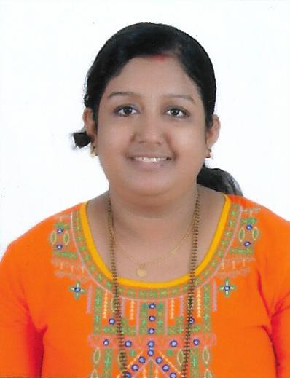  Personal Details  Date of Birth: 4th Nov 1995  Marital Status: Married  Nationality: Indian  Language: English, Hindi, Kannada, Tulu.  Visa Status : Visit Visa.  RAKSHA  B.Com (University of Mangalore)  Working Knowledge of:  TALLY ERP9 | Objective  To seek a growth oriented position in a challenging work environment where my knowledge and skills can be utilized and enriched in the accounting and administrative field.  Key Skills  - In-depth knowledge of the accounting principles, book-keeping practices, and financial accounting.  - Ability to communicate effectively and coordinate work with other staff members for day to day activities.  - Excellent in performing arithmetical calculations required for handling the accounts concerned.  - Aptitude to analyze data for better understanding and to detect discrepancies in calculating or posting the data in accounting books.  - Good in preparation of reports in Excel sheet with short cut keys.  - Ability to plan and complete the work in time.  Work Experience  - Was Working as part time Junior Accountant underUmeshRao Chartered Accountant India from Jan 2016 to may 2016  - Was working as Accountant under BalakrishnaBhat , Chartered Accountant India from June 2016 till November 2017 .  Employment History  BalakrishnaBhat and Umesh Rao Chartered Accountant,India as an Accountant from Jan 2016 till November 2017.  - Independently maintaining and handling day to day accounting transactions  - Independently handling coustmers accounts.  - Independently verify vendors invoices and generate cost sheet for superiors approval and prepare receiving instructions and advice coustmer on shipment and delivery details.  - Attend to and follow-up on customers’ enquiries and requests.  - Maintain reports, process documentation .  - Preserve proper records keep all assigned files up-to- date.  - Produce monthly reports and other reports on purchasing, consumption and supplierperformance.  - Perform variety of accounting functions including examination, analysis, maintenance,reconciliation and verification of financial records under direct supervision.  - Receive, record and bank cash, checks and vouchers. Issue receipts, refunds, credits or changedue.  - Assist Chief Accountant in accounts finalization, monthly book closing procedures and inpreparing financial statements such as balance sheet and profit & loss statement.  - Ensure all accounting process such as handling complete books of accounts independently upto completion are carried out according to standards with zero error tolerance.  - Work cooperatively with banks, auditors and all parties dealing with the company.  - Help in continually reviewing and setting up improvements to current procedures.  - Experience in Fixed Assets Verification and reporting the same in Excel, and Maintaining the Fixed Assets Register.  - Experience in Stock audit and reporting the same in Excel.  - Auditing experience: Auditing the books of accounts, stock audit, FAR verification, etc..  - Have knowledge in filing VAT 100.  - Vouching the books of accounts.  - Wide knowledge in investment proof verification for income tax purposes.  - Manual filling of ITR and applying for TAN.  - Have Knowledge in Tax Auditing .  - Have knowledge in TDS &GST .  - Good communication Skill in English .  Computer Skills  Well acquainted with MS Office (Word & Excel), Tally Version 7.2, ERP 9,Win man CA ERP, SAP, Accounting Wings .  - Persumed Practical Accounting And Taxation Under UmeshRao , Chartered Accountant  - Persumed competitive exam training  - Persuming MBA in Finance in Sikkim manipal university  - Persumed SAP in MICE institution and scored 93%.  Education  Course University / Institution Year of Passing Percentage  Master of Business Administration (MBA in Finance) Skkim Manipal University Manipal 1st Sem 56%  Bachelor of Commerce (B.Com.) University of Mangalore Sri Dhavala College 2016 79.45%  Pre-University (PUC) Commerce Jain P.U. college Moodabidri Karnataka 2013 86.33%  Secondary School ST.Thomas English Medium School Alangar 2005 76.32%  Declaration  I hereby declare that all the above furnished details are true to the best of my knowledge, I amalso confident of my ability to work in a team.

