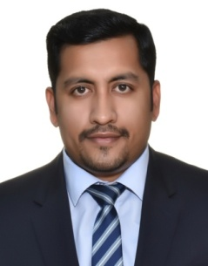
Tobin
Email id: tobin.376514@2freemail.com
C/o-Phone: +971 50 5891826

Career Objective:

To acquire a highly challenging position that would optimize my knowledge ,offer opportunity for personal growth career advancement, personality development and fully utilize my abilities in an environment where I would learn and prove by worth to be an asset to the organization.

Core Competencies:

- CRM Software Operation
- Corporate Sales
- Training & Mentoring
- Client Servicing

Professional Skills:

- Individual focus on existing customers and marketing new customers.
- Relationship building skills with customers
- Time Management,
- Planning and organizing skills
- Action Oriented
- Handling of MIS,
- Employee Database
- Effective communicator with excellent analytical and interpersonal skills

Educational qualification:

MBA (HR & Marketing)
Bangalore University - June 2015
BBA
University of MG - December 2011

Professional Experience:

HDFC BANK LTD
Sales Manager - Home Loans
September 2016 - September 2017

- Ensure that all product applications are filled accurately, within the agreed timeframe and all the required documents are obtained to avoid re-work
- Ensure that all customer applications submitted are within bank policy guidelines
- Make sure consistently a high level of customer service is maintained at all times.
- Coordination with BM's and RM's for setting and achieving their Annual Targets
- Follow up and close sales leads referred by Sales executives and other segments
- Attend weekly and monthly team and area sales meetings to review performance.
- Conduct activity sessions at customer sites for product awareness.
- Generating Daily, Weekly and Monthly Disbursement Report
- Recruiting, Training & Ensuring quality deliverable in market.
- Handles a team size of 6 BDR's, 1 DSA and 2 CONNECTORS
- Handles branches and RM's

GETIT GROCERY PVT LTD
Senior Executive – Marketing
January 2016 - September 2016

- Implementing the Marketing Ideas according to Kochi.
- Training and mentoring the manpower for the marketing activities( Promoters and D&P Executives.
- Co-Branding Tie-ups
- Coordinating & Monitoring all the BTL activities in Kochi
- B2B Marketing
- MIS Handling.

GREEN READYMADE STEEL PRODUCTS INDIA PVT LTD.

Operastion Executive August 2014 - December 2015

- Managing all core accounts process in the company (collection of bills, making settlements, verifying statements, maintain records of employees, etc.)
- Execution of payroll progress.
- Assisting the Chief accountant in salary payment for Employees
- Maintaining records of employee’s database.
- Finalize the day’s balance, and prepare and print management reports.
- Have been awarded as the Best Employee for the month of January, March and August.
- Have achieved sales target for the month of January and March and been rewarded with gifts and
UNICORN AUTO, MAHINDRA TWO WHEELER
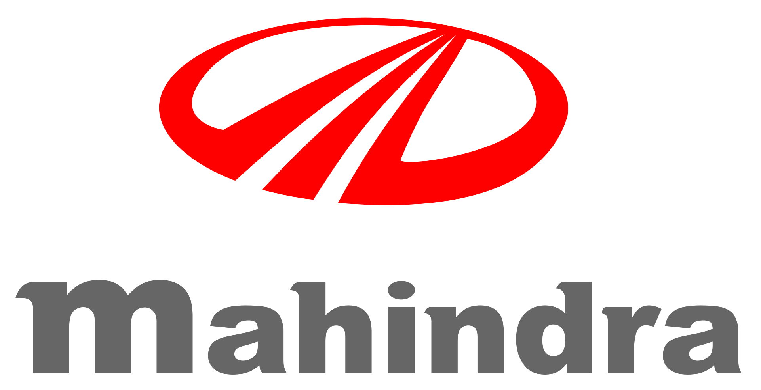
Sales Executive -
July 2011 - December 2012
- incentives.

- Marketing Targeted Automobile Products
- Solving the problem and queries of existing dealers and customers.
Making daily call reports and sending them to the seniors
- Going on field with seniors to study the market and customers of the company
- Generating enquiries for the company and converting them to customers
- Have been successful in accomplishing the monthly targets
- Rewarded with incentives and gifts for achieving more sales
Personal details:

Date of Birth 08-12-1987

Nationality Indian

Marital status Married

Languages Known English, Hindi, Malayalam

Date of Expiry 16/11/2018

Place of Issue Trivandrum

Declaration:

I hereby declare that the above given details are true to best of my knowledge and belief.

