Mohamed

Civil Quantity Surveyor cum Drafter

 |  | Address: | Abu Dhabi, UAE
C/o-Mobile: +971501685421
Email: mohamed.376523@2freemail.com |  | Nationality: | Indian
 |  | Date of Birth: | 06 November 1993
 |  | Visa Status: | Visit Visa

EDUCATION

CAREER OBJECTIVE

To obtain a challenging position that provides me opportunities to
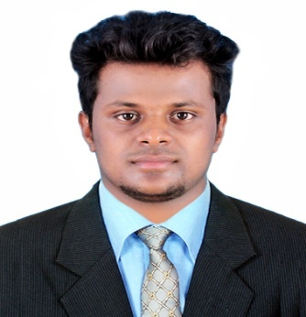
exploit my knowledge and extensive development skills to the extreme levels of my ability and to continually upgrade myself to the highest levels of expertise enabling the organization to achieve its target and growth.

PERSONAL ATTRIBUTES

- Master Diploma in Construction Management from the institute of Quantity Surveyors Calicut, India.(Gulf Oriented)

- Having 1 years of experience as an Quantity Surveyor.

- Highly proficient in Quantity take off from the drawings.

- Preparation of measurement sheets and assists in quantity take-off for tenders as per specification.

- Preparation of Reinforcement schedule for estimating.

- Checks the allocation of manpower and productivity.

- Preparation of BOQ.

- Dedicated, hard working and result oriented.

- Be quick to learn with strong attention to detail.

- Having good Communication and Correspondence skills and Co ordination.

Master Diploma in Construction Management

Institute of Quantity Surveyors Calicut-Kerala
CAREER

Quantity Surveyor at Centre for Construction Management Calicut-Kerala (Gulf Oriented)
(4th July 2016 – 23rd June 2017)
Responsibility:
- Preparation of measurement sheets and Assists in Quantity take-off for tenders and Finishing.

- Prepare Reinforcement schedule for estimating.

- Find out the area for Shuttering.

- Prepare cost estimates as required and Preparation of BOQ.

- Assist in estimation of direct costs for tenders and checks the allocation of manpower and productivity.

- Preparation of BOQ.

- Weekly site inspection.

Projects: Included Gulf projects : Al injaz, Fa Baker, Tameer, Cleaster and somany projects

Site Engineer with Autocad Draftsman at Ijan Builders Tirur-Kerala
(5 month from 22nd June 2015)
Responsibility:

- Prepare of working plans and details according to dimensional specification.

- Modify drawings as directed by the engineer.

- Checking of drawings and measurements.

- Submission of drawings to the Panchayath.

- Site Inspection

EDUCATIONAL QUALIFICATION

- Completed Diploma in Civil Engineering (2015) From the Oxford polytechnic,Bengaluru - Department of Technical Education, Bengaluru, Karnataka- India,

- Completed Vocational Higher Secondary (2011) from the GVHSS Kalpakanchery, Malappuram - Board of Vocational Higer Secondary Examination, Kerala - India.

- Completed SSLC (2009) from the GVHSS Kalpakanchery, Malappuram - Board of Public Examination Kerala- India.

COMPUTER SKILLS
Design software : AutoCAD. Adobe Photoshope
Packages : MS office, Adobe.
Operating Systems : Windows XP/7/8

LANGUAGES KNOWN
Languages | Read | Write | Speak
ENGLISH | Excellent | Excellent | Excellent
ARABIC | Excellent | Excellent | Average
MALAYALAM | Excellent | Excellent | Excellent

PERSONAL PROFILE
Gender : Male
Date of Expiry : 11/08/2025
Languages Known : English, Malayalam and Tamil
Visa Status : Visit visa,

DECLARATION

I hereby declare that all the information given above are true and correct with the best of my knowledge and I bear the responsibility of the above-mentioned particulars.

Place :

Date :

Mohamed

