SANTHOSH

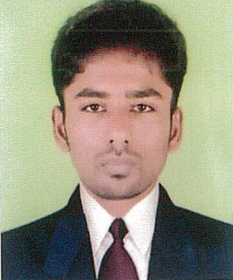

C/o-Mobile No : +971 501685421
E-Mail ID - santhosh..376527@2freemail.com
Abu Dhabi.
Career Objective
To work in a creative and challenging environment using best skill and hard work where I could constantly learn and successfully deliver solutions to problems for the advancement of the organization
Career Snapshot
M/S.N.S.K ABC BEARINGS PVT LTD – India as Quality Technician June 2016 – June 2017
Key Deliverables:
- Responsible for Incoming parts Quality.
- Analysis daily supplier related quality issues.
- Problem solving by 7 QC tools application.
- Continuous improvements thru SPC at supplier facility
- Coordinate between process team and supplier to establish quality standard
- Hold regular weekly meetings with supplier to enhance the product & process Quality.
- Implementation of 5S system
M/S. Visteon Automotive systems India.,as a Quality Technician
June 2015 – June 2016
Key Deliverables:
- Responsible for Incoming parts Quality.
- Analysis daily supplier related quality issues.
- Problem solving by 7 QC tools application.
- Continuous improvements thru SPC at supplier facility
- Coordinate between process team and supplier to establish quality standard
- Hold regular weekly meetings with supplier to enhance the product & process Quality.
- Implementation of 5S system
M/S.UCAL FUEL SYSTEMS LTD as Quality Technician May 2014 – May 2015
Key Deliverables:
- Responsible for In-process quality
- Online patrol inspection and reporting the quality issues
- Weekly quality analysis & Corrective action implementation through 7QC Tools 5S
- Implementing competitive methodologies like Kaizen, Poka Yoke etc
Academics
Qualification | Board/ University | Year Of Passing | Percentage
Diploma in mechanical Tool & Die Making | Sri Sakthi Polytechnic College | May 2014 | 74%
10th STD | Goodwill matriculation higher secondary school – Tirupattur | 2009 | 70%
Strength
- Self-Motivated
- Comprehensive problem solving abilities
- Excellent verbal and written communication skills
- Ability to work with different cross functional team
Industrial Visit
- CIPET, Chennai - Visited Injection moulding process and Tooling
- CNC (Computer Numerical Control) operations
Computer Proficiency
- Languages : Basics of C
- Operating system : Windows 98, 2000, XP
- Application Software : Microsoft office package, Oracle, CAD, QAD application.
Personal Profile
Date of Birth : 26.12.1995
Marital Status : Married
Languages known : English, Tamil, Malayalam

DECLARATION
I hereby declare that the above information are true and correct in my knowledge.
The information given in this CV is accurate and fair reflection of my ability.

Thanks and Regards,
Santhosh

