SINU

Sinu.376530@2freemail.com
C/o-Mobile: +971-502360357
Dubai
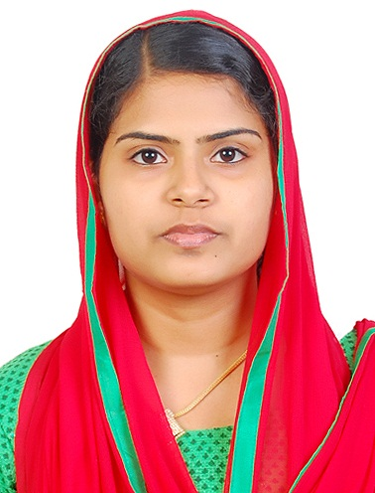

Career Objective:

To be a part of a reputed organization, that will provide me a good platform to utilize my teaching & administration skills and will help me to grow my career and for the development of the organization. I am willing to work as a key member in challenging & creative environment.

Profile Summary:

- An enthusiastic and dedicated team player with highly motivated and leadership skills.
- Eager to learn new technologies and methodologies.
- Always willing to innovate the new things which can improve the existing technology.

Personality Traits:

- Highly motivated and eager to learn new things.
- Confident & Optimistic.
- Ability to produce best result in pressure situation.
- Excellent communication skills in written and verbal both.
- Strong motivational and leadership skills.
- Ability to work as individual as well as in group.

Sl# | Degree/Programs | Institution | Board/University | % | Year
1 | Bachelor of Education  (Natural science) | M E S Training College,  Aluva, Ernakulam | Mahatma Gandhi  University | 82.2 | 2013-2014
2 | Master of Science in Marine Biology (Equivalent to M.Sc Zoology) | Cochin University of Science and Technology, Kochi, Kerala | Cochin University | 76.6 | 2011-2013
3 | Bachelor of Science in Zoology | St.Xaviers College, Aluva, Ernakulam | Mahatma Gandhi  University | 80.6 | 2008-2011
4 | Higher Secondary | Christava Mahilalayam Higher Secondary School, Aluva | State Board of Higher Secondary Examination | 80.7 | 2008-2006
5 | S S L C | Christava Mahilalayam Higher Secondary School, Aluva | Board of public Examination | 79.9 | 2006
Educational Qualification:

Experience Details:

Eight months experience as guest lecturer in zoology department from St.Xaviers College, Aluva, Ernakulam (part time)

Training details:
Sl# | Field | Institution
1 | On board experience in estuarine pelagic and benthic sampling | Cochin University of Science and Technology, Kochi, Kerala
2 | Sailing, scuba diving and snorkeling Experience | Lakshadweep Administration, Govt. Of India

Dissertations:

- Prevalence of Various Bacteria in Blood Infection, 2011, under the Department of Zoology, St.Xaviers College, Aluva.

- Distribution and abundance of meiobenthic fauna in the southern part of Cochin estuary, 2012-2013, under the Department of Marine Biology, Microbiology and Biochemistry, Cochin University of Science and Technology, Cochin.

Professional Experience:

Ecology
  - Sample collection, Preservation, Identification and counting of meiobenthos.
  - Analysis of physico-chemical parameters of pelagic and benthic habitat.
  - Identification of phytoplankton and zooplankton.

Microbiology
- Sterilization techniques.
- Preparation of various media.
- Isolation and purification of microbes.
- Preparation and maintenance of pure culture.

Instruments Familiar
- Microscopy
- Spectrophotometer
- pH meter
- PCR
- Particle Size Analyser
- Polyacrylamide Gel Electrophoresis.

Seminars Attended:

- National Seminar on Bioinformatics in Marine Biology: Next Generation Sequencing Technologies and Applications, 2013 at Kochi, organized by University Grants Commission, Govt. of India.
- National Seminar on Health and Environment, 2013 at Kochi, organized by Swasraya Bharat 2012.
- National Seminar on Greening the Forests for Safe Living, 2011 at Kochi, organized by Swasraya Bharat 2012.

Professional Affiliations:

Member of Society of Marine Biologists, India

Personal Details:
- Date of birth 11.12.1990
- Sex Female
- Marital Status Married
- Languages Known English, Malayalam
- Nationality Indian

DECLARATION

I hereby declare that the information given above is true to the best of my knowledge and belief.

SINU

