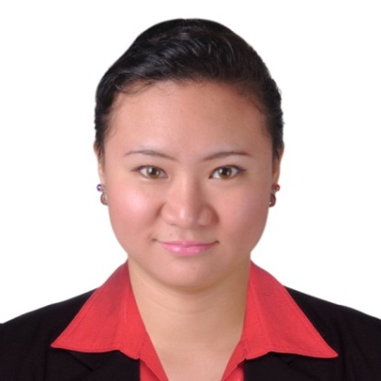
ROSANNE, PRN, CPC-a
Abu Dhabi, UAE
Contact Numbers: C/o 971501685421
Email Address: Rosanne.376535@2freemail.com

APPLYING FOR THE POSITION OF: MEDICAL CODER/ INSURANCE COORDINATOR

Profile:
More than 5 (five) years of working experience in a Healthcare industry as:
- Data analyst for 2 years and 10 months in insurance and collections
- Recently joined Radiology Support Specialist team
- Previously worked as an data abstractor for an American Insurance
- Clinic nurse or OPD nurse for 1 year in Clinic
- General nurse (Inpatient/ OR/DR/ OPD) for two years in a primary hospital
- Certified Medical Coder
Objectives:
To be able to professionally utilize my medical coding profession with adept coding expertise and proficiencies and the aid of my previous work experience in an challenging and captivating working atmosphere in Healthcare industry.
Professional Experience:

- September 01, 2017- October 31, 2017
Radiology Support Specialist
Shearwater Health Advisors INC

- June 01, 2015- August 31, 2017
Data Analyst
Shearwater Health Advisors INC

- January 26, 2015- May 15, 2015
Data Abstractor/ HEDIS Abstractor
Shearwater Health Advisors INC

- July 2014-December 2014
Clinic Nurse (OPD)
Del Mundo Dental Clinic and Specialty Clinic

- May 2012- July 2014
Staff Nurse (OPD/Inpatient/OR/DR/ER)
Vian Family Hospital II (Primary Hospital)

- December 2011- May 2012
ER Nurse
Blessed Trinity Hospital (Secondary Hospital
Qualification Profile:
- Extensive knowledge of medical terminology across a broad range of medical practice areas
- Strong understanding of ICD-10-CM and CPT requirements and procedures
- Good multi-tasking abilities
- Experience with fast-paced medical care environments
- Possesses knowledge of utmost quality related to medical coding methods and guidelines, including ICD-10-CM and CPT
- Excellent data entry skills
- Good interpersonal skills and the ability to function as a team member
- Analyzing medical data and entering it in the form of precise medical codes in the programmed patient record software

Job Description as Radiology Support Specialist
- Responsible for providing exceptional service to hospitals and radiologists to ensure that the work flow through the reading center is maximized.
- Utilization of healthcare software to draft and verify radiology examinations.
- Efficient drafting of x-rays and verification or exception of cross sectional examinations.
- Focus on assigned duties in a high volume client service center.
- Generate process improvement ideas and take action on ideas.
- Verify ICD-10 codes for billing purposes.

Job Description as Data Analyst
- Abstract data from demographics/ ledgers and/ or records that is needed and important in entering in the system.
- Interpreting data, analyzing results and filter documents that are least important but letting client know the reason for the elimination
- Compute for the proper balance based on the procedures done to the patient/ client and removing excess charges
- Locate and define new process improvement opportunities
- Acquire data from primary or secondary data sources and maintain databases
- Verifying correct information given using tools that is limited and within the scope of the account
- Identify, evaluate and implement external services and tools to support data validation and cleansing
- Monitor and audit data quality

Academic Qualifications:
- Certified Medical Coder, March 2017 by AAPC (American Academy of Professional Coders)
- Philippine Registered Nurse, PRC, Republic of the Philippines, July 2010
- Bachelor of Science in Nursing, Arellano University June 2005-March 2009

Personal Information:
Age: 30 years old
Gender: Female
Date and Place of Birth: December 14, 1987, Quezon City, Philippines
Status: Married
Height: 5’1’’
Weight: 147.71 lbs
Nationality: Filipino
Visa Status: Tourist Visit Visa Until: January 30, 2018

I hereby certifiy that all of the information mentioned above is true and correct in my personal knowledge.

Rosanne

