Curriculum vitae
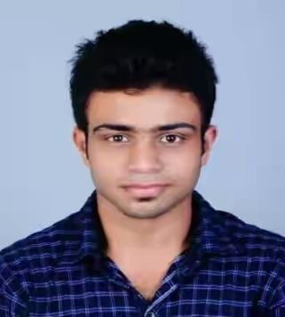

SHAHEEN

MOBILE C/o 971504973598 • E-MAIL- shaheen.376536@2freemail.com

Objective

Possessing the necessary skills and experience in addition to excellent communication. interpersonal and analytical skills, I am seeking a challenging position that will provide me the opportunity to utilize my knowledge and skills in order to enhance my competencies whilst achieving the company's goals and objectives.

Experience

- Sales Executive in Benco International (oman) (1month)

- Worked As Accountant in Dayana Readymade (2 year)

- Purchase Manager in Dayana Readymade (1 year 10 month)

Skills

- Adapt to a culture that nurtures and encourages service excellence, quality, and a mind-set of getting it right the first time, every time.

- Stand out as an excellent team player while representing and promoting teamwork and ensuring high morale of the staff.

- Establish a positive, productive working environment by understanding the need of all staff members.
- Performances to achieve corporate objectives.

- Specialist In Microsoft Excel basic and Advanced.

- Implementation of systems to motivate staff members in order to facilitate/enhance their individual.

Expertise

- Accounting

- Client Handling

- Customer Service

- Logistics

- Microsoft office

Extracurricular Activities

- Best Manager in college event 2017

- Member of college Magazine Advertisement team

- Member of Kerala Emergency Team

- Participant of the State Level Best Manager competition

Education

UNDERGRADUATION (MESponnaniCollege–Kerala) 2015-2018

Subject Included

B.com, Specialised in (Finance)

Percentage Scored : 70%

SCHOOLING

- Government Higher Secondary School Thrikkav Grade(11-12) Percentage Scored: 85%

- Achutha Variour High School Ponnani Grade (10th) Percentage Scored: 75%

Personal Details

Gender

Male

Date of birth Marital Status Driving License Languages Fluent

3rd November 1995

Single

Yes (INDIAN)

English, Hindi, Malayalam, Tamil,

Arabic (Beginner)

Declaration

I hereby declare that the above written particulars are true to the best of my knowledge and belief.

(SHAHEEN)

