Arsalan
C/o-Mobile: +971505891826
E-mail: arsalan.376551@2freemail.com

Personal Profile | 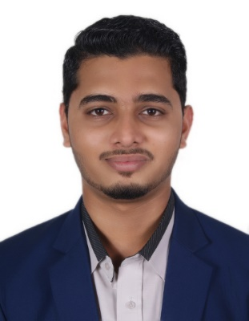  DOB: August 26, 1995  Languages: Fluent in English and Hindi  Nationality: Pakistan.
Career Objective | Seeking a position in an environment that offers challenges, to enhance my career and that offers me opportunities, which will help me and the company's advancements, efficiently and productively.
Experience | FEB 2017 – Present Sales Executive  DU Emirates Integrated Telecommunications Company, Dubai, U.A.E.  - Listen to customer requirements and present appropriately to make a sale.  - Made 100+ outbound calls per day to prospective customers.  - Maintain and develop relationships with existing customers in person and via telephone calls and emails.  - Challenge any objections with a view to getting the customer to buy  - Negotiate the terms of an agreement and close sales.  - Advise on forthcoming product developments and discuss special promotions  - Built immediate rapport with clients through friendly and engaging attitude.  JAN 2016-DEC 2016 Advertising & Sales Operations C.N.B.C Television, Karachi Pakistan.  - Experience in Advertising Operations, Sales Operations, Media Planning, Campaign Management.  - Inbound and outbound calls handling.  - Focused on achieving continuous improved business performance and experienced in working with cross functional teams across the globe.  - Excellent reporting product marketing and testing, customer acquisition & engagement programs.  - Excellent communication skills with internal staff and as well as outside reporters etc.  JAN2015-DEC 2015 SalesRepresentative andCashier, Splash, Ocean Mall, Karachi Pakistan.  - Handling and dealing with day to day customers.  - Excellent in maintaining relationship with customers and staff.  - Expert in solving customer’s problems and handling complaints.  - Handling sales and customer service at the showroom.
Education | 2016-2017Government Degree Commerce College,Graduation is  inProcess,Karachi Pakistan.  2014-2016St. Patrick’s College, Intermediate, Karachi Pakistan.  2012-2014St.Paul’s English High School, Matriculation, Karachi  Pakistan.
Skills and Achievements | - Successfully completed computer programming Language [C language] fromAptech Computer Education Karachi – Pakistan.  - Excellence over Microsoft Word, Microsoft Excel, PowerPoint, MAC and Research.  - Excellent time Management skills, Goal Oriented, Responsible, Self-Motivated and Ability to work Under Pressure.  - A Team Player, Motivator-Sharp Analytical Abilities, Quick Learner, Ability to Build Relationships, Correspondence skills, Strategic Thinker and Trouble-Shooter.
Interests | Travelling, Photography, Cricket, Football, Bodybuilding, Puzzles Crosswords, Car Restoration, Socializing and Event Planning.
Reference | Can be gladly furnished upon request.

