MANU
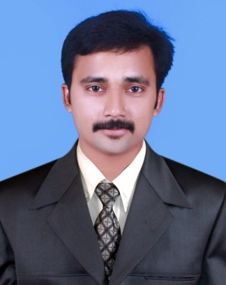
PERSONAL PROFILE:

DATE OF BIRTH:
28THMAY 1990

GENDER:
MALE

NATIONALITY:
INDIAN

MARTIAL STATUS:
SINGLE

DRIVING LICENSE:
INDIAN LICENSE

VISA STATUS: RESIDANCE VISA

EDUCATIONAL BACKGROUND:

DRAUGHTSMAN CIVIL- 2010 -12
HIGHER SECONDARY - 2005-07

COMPUTER SKILLS:
AutoCAD, 3ds MAX, SKETCH UP
V-RAY, MS Word, Excel, Outlook Express, Microsoft Windows, Microsoft Office

LANGUAGES KNOWN:
ENGLISH, HINDI, MALAYALAM, TAMIL,KANNADA.

HOBBIES AND INTERESTS:
MUSIC, DRIVING, SOCIAL MEDIA

Architectural Draughtsman and 3d Designer
C/o-Mobile No: +971501685421
Email: manu.376553@2freemail.com

OBJECTIVE:

A challenging career which favour learning, creativity, and provides exposure to new ideas and that prompt personal and professional growth along with the organization

PROFILE:

Works well independently, organised and capable to perform interior & exterior designing in a pressurised work environment. Possess excellent communication, inter personal and computer skills with two year UAE experience.

Resume HiGHLIGHTS &SKILLS:-

- Planning, designing &implementation of drafted plan.
- Result Oriented Approach.
- Develop entire concept using fixtures & furniture.
- Effective Presentation Skills, both Verbal and Written.
- Commitment to Continuous Learning & Skill Development.

Work Experience:

DESIGN COMBAINE ARCHITECTURE & INTERIOR (KERALA, INDIA).
Designation:ArchitecturalDraughtsman&3D designing.
Period: From 2012 to 2014

PRAKIRTHI ARCHITECTURE& INTERIOR (KERALA, INDIA).
Designation: Architectural Draughtsman& 3D designing.
Period: From 2014 to 2015

STRAIGHT LINEDÉCOR LLC (ABU DHABI, UAE).
Designation: ArchitecturalDraughtsman &3D designer.
Period: From 2015 MARCH 26 to TILL DATE

Job Description:

- Prepare Architectural drawing for interior and exterior.
- Expert in preparinginterior shop drawing.
- Prepare working drawing for interior and exterior.
- Prepare BOQ forinterior
- Prepare 3D design (Auto cad and 3ds max-v ray ,sketch up ,
- Prepare Engineering submittals.
- Co-ordination with client, site visits, contractors.
- Creation of innovative design using various materials
- Supervision of the designed plan.
- Designed commercial places using high-tech design.

Main projects:
- Falcon mall kunnamkulam( 2012 to 2014 )
- Residence for Binoj( 2012 to 2014)
- Good shepherd school Thrissur(2012 to 2014)
- ST. Xavier school Thrissur(2012 to 2014)

- Arabic collage mukkam(2014 to 2015 )
- Masjidhkalpatta(2014 to 2015 )
- Jose cinema hall Manathavady(2014 to 2015 )

- Cigars shop Abu Dhabi ( 2015 to 2016 )
- Halim jewelry Dubai ( 2015 to 2016 )
- First clique restaurant Abu Dhabi (2015 to 2016 )
- Johnny rocket Dubai (2015 to 2016 )
- Amor cafe Ras al Khaimah(2015 to 2016 )
- Scsshin Spa Dubai (2015 to 2016 )
3d Designs

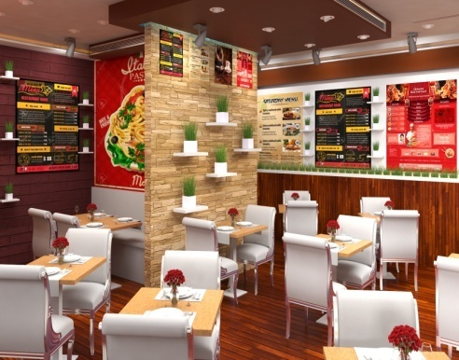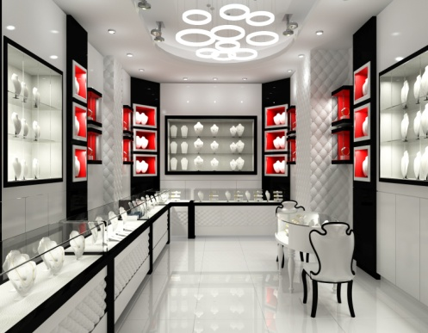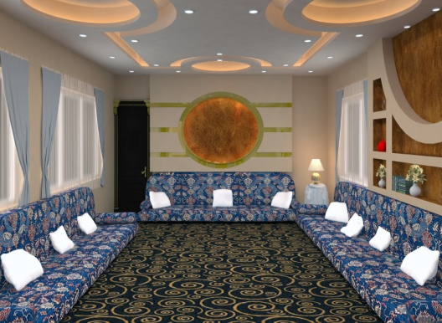
Restaurant design Jewelry design Majlis design
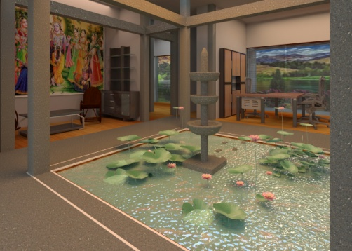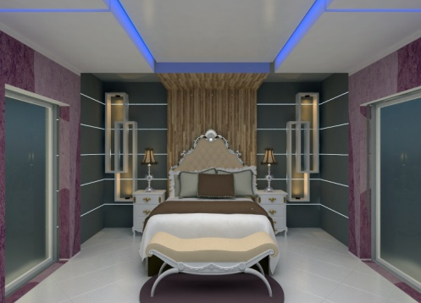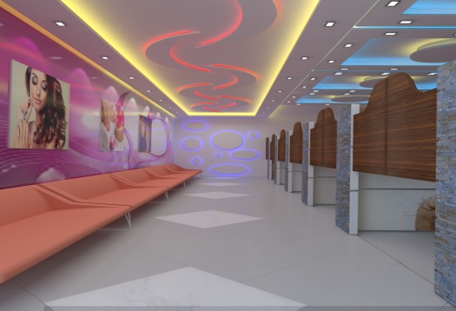
Interior designBed room design Saloon design
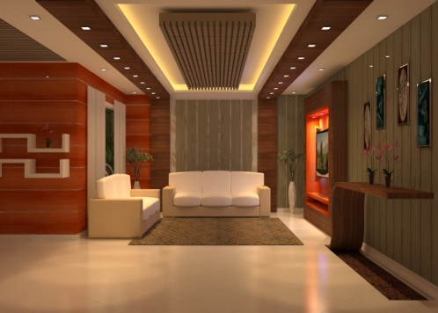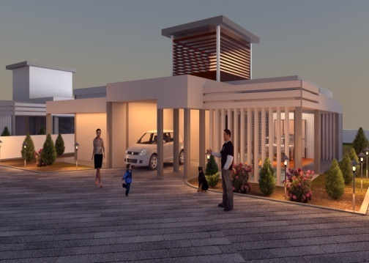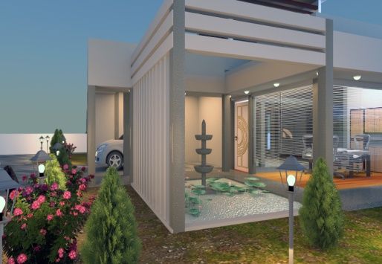
Living room designExterior design Exterior design

DECLARATION:

I hereby declare that the information furnished herein is true and correct to the best of my knowledge and belief.
Yours faithfully,

MANU.

