Qadrey

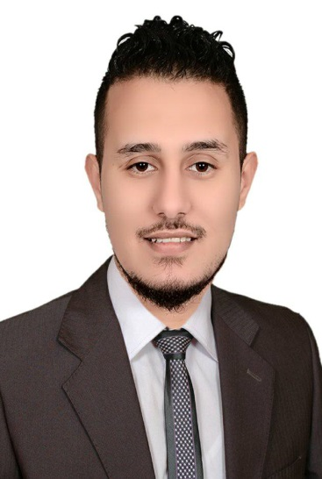

Personal data:

    - Nationality : Egyptian
    - Date of Birth : 7, 9, 1993
    - Religion : Muslim
    - Marital status : Single
    - Phone number : +971505891826
    - Email : qadrey.376571@2freemail.com
    - Military service : I did military service
    - Driving license : Valid driving license in Egypt

Objective

    - To acquire a challenging position with a progressive and professional company offering multi opportunities in the field of accounts and banking and marketingwhere my skills, talents and you can see results in a short span of time in which my contribution shall achieve to the professional and financial objectives of the organization .

Education:

    - Education : Average Institute of Social Service
    - Graduation :May 2015
    - GraduationEvaluation : Good

Language:
- Arabic (Native Language)
- English (Good)

Computer Skills:

    - Windows 98 / ME / XP/win7.
    - Microsoft office (Word, Excel, Power Point, Access).
    - Good experience with computer's software.
    - Very good at Web searching and other internet skills.

Recent Professional Experience

- September2017—December2017:Green Fields company for dairy products and food industries, desouq kafr el-shiekh.

Position: marketing.

- December 2014—December2015: Green Fields company for dairy products and food industries, desouq-kafr el-shiekh.( I was working during the study )

Position: Sales Representative

Skills & Attributes

    - Consistency in Quality Work and Dedication.
    - Interactive & fast enough to learn new technologies & languages.
    - Excellent telesales skills.
    - Excellent negotiating &persuading skills
    - Having the ability to work with team.
    - Having the ability to work under pressure.
    - Having good communications skills with client.
    - Hard worker since I used to work for a long period of time.
    - Ability to learn, adaptable, creative, problem solving skills, self-motivated.

Notes
    - I have a lot of colleagues, friends & contacts here in Emirates, Which will allow me to get new customers.
    - Will Be Readily Available on Request.

Strengths
    - Aggressive to work up to any Extent.
    - Pragmatic Approach toward life.
    - 100% mobile (about Job location).
    - Friendly.
    - A good listener.
    - Supportive and result oriented.
    - Love to work under pressure and stress.
    - Highly Systematic at work

AREAS OF EXPERTISE
    - Maximising Opportunities - Customer Satisfaction
    - Customer follow up - Relationship building

It makes me proud if I join your teamwork

