IMRAN
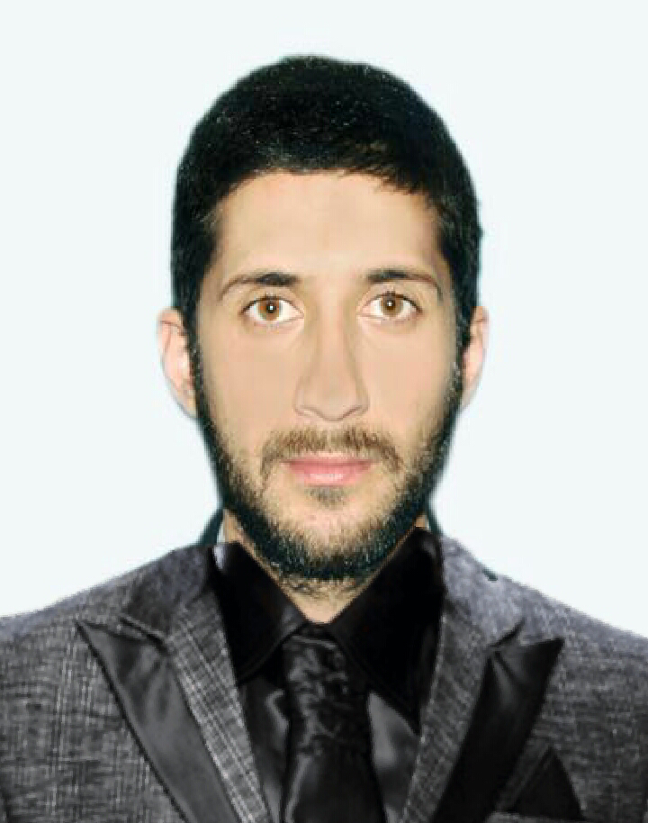
DUBAI-U.A.E
DATE-OF-BIRTH: 26-08-1990

C/o-MOBILE: +971-50973598

EMAIL: Imran.376590@2freemail.com

PERSONAL PROFILE
A naturally approachable person, possessing a polished and professional demeanour and an ability to communicate at all levels. An organized, resourceful and achievement orientated individual having achieved MBA (3.5 YEARS) Total No of Experience 6.5 year.Not only possesses the acumen to deliver a variety of skills developed both academically and commercially,but also has the ability to consistently and accurately deliver tasks within stringent timescales.Analytical and flexible, possesses first class communication skills and the ability to work well under pressure in fast paced environments. To becomes a part of an organization where, I could use my potential to its maximum benefits. I want a position in a progressive organization, where I could use my sound knowledge and skills to achieve organizational goals and objectives.

KEY SKILLS

Strong academic business skills and is now ready to transfer skills to the workplace | Excellent leadership skills, developed through studying and in the commercial arena
Demonstrates commercial awareness developed from work conducted throughout studies | Hard working, self motivated with the maturity and flexibility to work efficiently in a team environment
Excellent communicator; confident addressing large groups in a clear and concise manner | Analytical with a strong attention to detail; delivers projects and tasks within set timescales
Maintains and develops relations with colleagues, management and 3rd parties

EDUCATION& QUALIFICATIONS
DEGREE PROGRAME | INSTITUTE/UNIVERSITY |  |  | YEARS
MASTER IN BUSINESS ADMINISTRATION(MBA) | UNIVERSITY OF AZAD JAMMU AND KASHMIR MUZAFFARABAD |  |  | 2010-2014
BACHELOR OF COMMERCE(B.COM) | UNIVERSITY OF AZAD JAMMU AND KASHMIR MUZAFFARABAD |  |  | 2008-2010
HSSC | BOARD OF INTERMEDIATE AND SECONDARY EDUCATION MIRPUR |  |  | 2006-2008
SSC | BOARD OF INTERMEDIATE AND SECONDARY EDUCATION MIRPUR |  |  | 2004-2006

TITLE: FINANCE RESEARCH PROJECT
DOMAIN: THE IMPACT OF WORKING CAPITAL MANAGEMENT IMPACT ON FINANCIAL PERFORMANCE EVIDENCE FROM PAKISTAN.
Description: The purpose of this research study was to empirically explore the impact of working capital management on firm financial performance of chosen manufacturing firm listed in KSE.
TECHNICAL EDUCATION
DEGREE PROGRAME |  | INSTITUTE/UNIVERSITY | YEARS
SURVEYOR TRADE |  | PUNJAB BOARD OF TECHNICAL  EDUCATION, LAHORE. | 2010
CERTIFICATE IN AUTOCAD |  | SKILL DEVELOPMENT COUNCIL | 2011
CERTIFICATE IN INFORMATION TECHNOLOGY |  | SKILL DEVELOPMENT COUNCIL | 2012

WORK EXPERIENCE m
- Currently working in Royal falcon security ServicesLLC Abu Dhabi UAE.
- 1 year works in Pakistan international airline as afinance specialist.
- 2 year working in Glasko smith company ltd in Pakistan as an accountant.
- 1 year working in Pakistan Karachi steel millltd asa cost accountant.
- 2 year working in Pakistan tobacco ltd as aTreasury controller.
- 6 month internship in National Bank of Pakistan as an Accountant.

BUSINESS COMMUNICATION SKILL

DEGREE PROGRAME | INSTITUTE/UNIVERSITY | YEARS
CERTIFICATE OF PARTICIPATION  SEMINAR ON BUSINESS COMMUNICATION | UNIVERSITY OF AZAD JAMMU AND KASHMIR. | 12TH OF JUNE,2012

CAREER ASPIRATION
Throughout my life, I have always enjoyed engaging in business activity. I have carried out many different business activities, as a participant, a coach, a teacher and facilitator. I have always had a keen interest and have felt very passionately when it comes to the practical and theoretical work concerning business field application .This love of leadership/business practices and education has led me into business field.I am a highly dedicated business leader with a master degree in finance joint university of Azad Jammu and Kashmir in 2015 a place where I can develop, share and improve a dynamic team working environment. I am very eager to develop my experience and professional skill
INTEREST
A particular interest of mine is community development work in deprived villages and towns in developing countries. I also like listening to music, socialising with friends and playing and watching cricket.

REFERENCES AVAILABLE ON REQUEST

