Desire a position as an Architect at your rm , utilizing my knowledge of construction drafting, 3d visualization, materials and resources in order to bring projects to success.
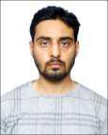

TALHA

RELEVANT EXPERIENCE

Skyline Architectural Consultants pvt. ltd (June 2017-November 2017)
  - Medical college, Faizabad
- International stadium, Lucknow

Ahmed Builders(2016)

Redevelopment Residential Project

Bobby Mukherjee & Ass.(2015)

    - Tulip Club House, Delhi
- Hiranandani Club House, Bangalore
      - Interior Project, Oman
  - Commercial Building, New Delhi

A.A.Designs(2013-2015)

    - villa project in kerala
  - interior project in bandra
- 3d modeling of home theater

Personal project

    - Residential house Lucknow
  - Interior designing of at in oshiwara
- Furniture design,kitchen design,door design,etc

ACADEMIC WORK

- thesis on virtual reality research and entertainment centre
    - city museum in Aurangabad
      - residential project in worli
  - vocational center in dahanu
  - sports center in navi mumbai
        - housing project
          - school project

ABOUT ME

I am more task-oriented than people-oriented, and I probably enjoy analyzingand solving problems. I probably like to getthings done with excellence and a focuson quality. Some of my interests andhobbies includes :
architecture | gadgets
travelling | swimming &gym
video games | 3d designing
technology | sci- movies

Visa Status : Visit (3 months)
C/o-Contact no.
+971-501685421
Talha.376604@2freemail.com

EDUCATION

Bachelor Of Architecture

rizvi college of architecture, Mumbai Univ. Completed in 2016

HSC

skd academy, lucknow
Passed in 2009

SSC

exon inter college, lucknow Passed in 2007

PROFICIENCY

autocad

sketch up

3ds max
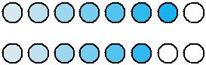

revit

vray

lumion
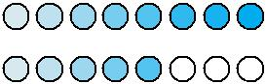

corel draw

photoshop

premiere

after effects
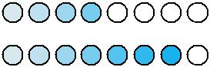

ofce suite

SKILLS SUMMARY

- Proven eye for detail in documentation - from design development through to construction

- Flair for both schematic and concept design
- 3D visualization
- Strong knowledge of construction methods and detailing
- Experience in producing planning and presentation drawings utilizing sketch up, photoshop, corel draw, 3dsmax, vray, lumion.

