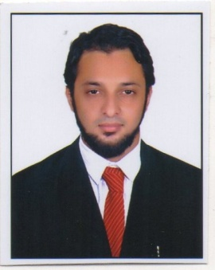
RESUME
SHAHID
Pharmacist (DHA Qualified) Mob: +971 501685421
E-mail Id: shahid.3766107@2freemail.com

Objective:
Seeking for a responsible Pharmacist position in a prestigious organization where I can utilize my active experience and skills for delivering promising work.
Qualification Highlights:
• I have been approved as Pharmacist Pharmacy (DHA-Health Regulation Dept)
• Proven Pharmacist with more than 4years of experience.
• Proficient in Microsoft applications like Excel,Word,PowerPoint Access and the
Internet.
Professional Highlights:
PLANET PHARMACIES LLC, (HEALTH FIRST PHARMACY), DUBAI UAE.
As a Pharmacist, 1 Years and 6 Months Experience.
• Ensured dispensing of medications as prescribed by medical doctors.
• Supervised the department and handled the purchase of medicines.
• Consulted with patients regarding the proper use and storage of the medication to ensure safety and avoid overdose.
• Offered recommendations to customers on over the counter medications for common ailments.
• Provided necessary information to prevent drug interactions including those involving herbal supplements.
• Provided patients with over-the-counter medication advice and information,including allergies, adverse drug interactions, and side effects.
• Provided drugs to the patients and counseling visitors.
After B.Pharmacy (Work Experience):
- PRABHU MEDICAL AND GENERAL STORE, Bidar-585401 (Karnataka) India

- As a Pharmacist, March 2011–June 2016.

- As a Pharmacist in Health First Pharmacy (Planet Pharmacies LLC) of 1years and 6 months of experience.

Educational Background:
Master of Pharmacy, 2013
Rajiv Gandhi University of Health Sciences Karnataka (RGUHS), Bangalore, India
Bachelor of Pharmacy, 2010
Rajiv Gandhi University of Health Sciences Karnataka (RGUHS), Bangalore, India
Skills:
•Good communication skills and analytical ability
•Positive attitude and mindset and willingness to take up challenging tasks
•Creativity, strategic thinking, high productivity and problem solving skills
•Inventory Control (Pharm2010 software)
Office Automation:
•Proficient in working on MS -Office (MS -Word, MS -Excel, MS -PowerPoint)
•Internet skills.
•Other technical skills knowledge of software installation, and hardware etc.
DHAExam Qualified:

• Approved as Pharmacist Pharmacy, Ref: DHA/LS, Dated: 21/04/2016

Registration (License):
• Registered Pharmacist approved by Karnataka State Pharmacy Council, Bangalore, Registration,Dated: 11/03/2011
Personal Details:
Date of Birth : 10thOct 1988
Gender : Male Marital Status : Married Nationality : Indian Religion : Islam
Languages Known : English, Urdu, Kannada, Hindi
(Arabic only Reading)
Hobbies : Reading, Playing, and Travelling
Visa Status : Employment visa

Declaration:

The above details furnished by me are true to the best of my knowledge and belief.

SHAHID

