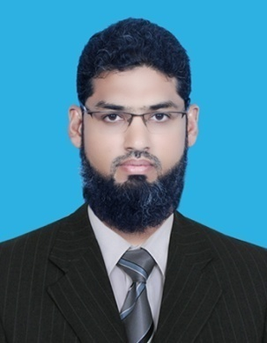
Talat

C/o-+971504973598• talat.376651@2freemail.com

Personal statement

My Name is Talat Raza, I am commerce graduate, have more than 16 years of experience in accounts & finance department, currently I have been doing my job as Accounts Officer since 2009, I am looking for a job where I can transfer my skills & abilities which I have learnt, I want to get more foreign experience so that I become a valuable part of your company's assets & can serve the company with enthusiasm & fantastic manner.

Work Experience

Accounts Officer, Dollar Industries Private Limited
08/2009 - Present
Responsibilities& Achievements
• Handling Account payable & Account receivable.
• Stock working including planning monthly stock taking,
• Import valuation, support in Local Purchase arrangement
• Monitoring on daily basis issuance of sales invoices,
• Preparation of Daily Sales & Purchase Report.
• To Check on daily basis, Bank, cash vouchers (Payments/ Receipts) & Journal Vouchers
• Maintaining Cash Book & Party Ledgers
• Preparing and maintaining statutory books of accounts vise, PL, journal, ledger, cash book and subsidiaries in compliance with time accuracy
• To Check Assembly of Manufacturing Item.
• Stock Report.
• Budgeting
• Supervise the staff of the department to make sure that all required tasks have been accomplished.
• Payment and Submit TDS Service Tax required Exp knowledge of Service Tax.
• To prepare working of monthly sales tax return. & check sales tax return from working.
• Financial Statements
Assistant Accountant, VIP Wears Private Limited
03/2007 - 07/2009
Responsibilities& Achievements
• Issuance sales Invoices
• Preparation of Bank Reconciliation Statement
• Maintaining Cash Book & Party Ledgers
• Accounts Payable
• Account receivable
• Bank Reconciliation
• Customers account reconciliation
• Supplier account reconciliation
• Financial Statements
Accounts Assistant, Khas Private Limited
04/2001 - 02/2007
Responsibilities
• Inventory Purchases
• Account payable
• Preparation of Weekly Contractor's Payment
• Maintaining Cash Book & Party Ledgers
• Accounts Payable
• Bank Reconciliation
• Supplier account reconciliation

Qualifications

University of Karachi
2005 - 2010
Undergraduate degree
Bachelor (Third)
Federal Urdu University Pakistan
2015 - 2019
Master's degree
Master of Arts (Economics, continues)
FUNCTIONAL SKILLS
- Busy Win ERP (Accounting Software)
- Fox Pro (Accounting Software)
- M.S Office (Word, Excel) & Internet
- Income tax, E-Filing,(Support)
PERSONAL ATTRIBUTES
- Interpersonal abilities.
- Dedication/Hard-Working/Work Ethic
- Responsibility
Positive Attitude/Motivation/Energy/Passion

