Resume

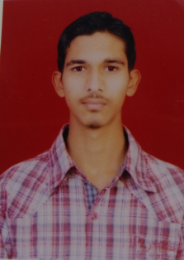
Akbar

C/o-Contact no: +971501685421

E MAIL: akbar.376655@2freemail.com

CAREER OBJECTIVE:

To Looking for a challenging career which demands the best of my professional ability in terms of technical and analytical skill and helps me in a broadening my current skill and Knowledge

EDUCATIONAL QUALIFICATION:

- B.tech Civil Engineering,CMRIT collage,Medchal,Hyderabad
jawaharlal Nehru Technological University. Hyderabad September 2013-May2017

- Intermediate MPC June 2011-Mrach 2013
Sri Chaitanya Junior College Kukatpally Hyderabad

- SSC June 2010-March2011
Mount Carmel High School .New Bowen Pally. Secunderabad

Projects
- Design of an auditorium using STAD PRO

Skills

- Operating System:windows XP,Windows 7

- Software:Micro soft office,AutoCAD

Job role:
Civil site Engineer

Technical Experience:
Elephant constructions,kompally,Hyderabad.
June 2017-December 2017

Type of constructions:

Residential buildings and industrial buildings

Job responsibilities:

- checking Drawing and executing site work
- Quality check up
- Ensuring Quantity as per BOQ
- preparing measurment book(M.B)for sub contractors
- weekly progress report
- Material Approval

Certification:
B.tech Civil Engineering certificate is attested by the UAE embassy

Passport Details:

Passport number:L41001733
Passport expiry date:18/08/2023

Visa status: visit

Date of entry:05-01-2018

Visa expiry date: 03-04-2018

PERSONAL DETAILS :

Gender : Male

Date of Birth : 12-01-1996

Nationality : Indian

Religion : Muslim

Language Known : English,Hindi,Telugu and Urdu

DECLARATION:

I hereby declare that the above mentioned particulars are true to the best of knowledge and belief.

Date:

Place:
(Akbar)

