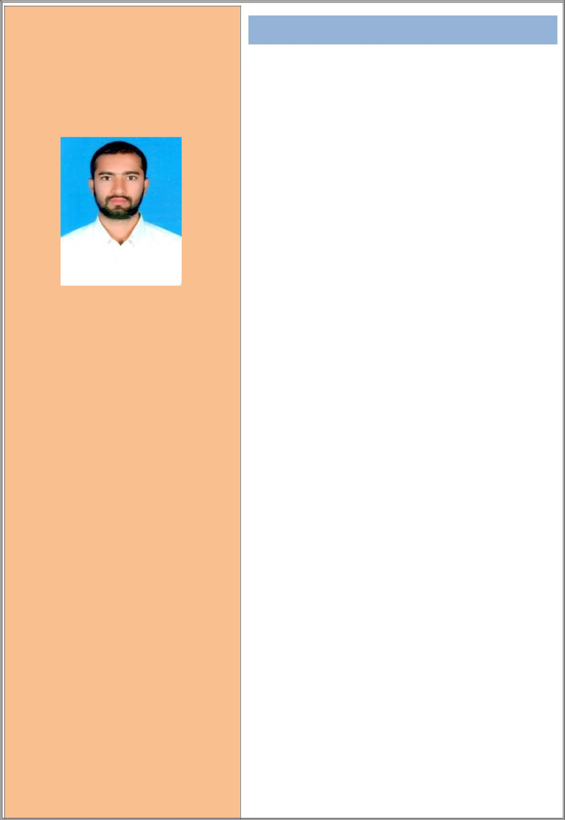
ILTAF

C/o-Mobile No : +971-501685421 Email: iltaf.376657@2freemail.com

PERSONAL INFORMATION:

- Nationality :Indian

▪ Gender :Male
- Date of Birth : 19th May 1996
- Marital Status: Single

▪ Visa Status :Visit Visa

LANGUAGES SKILL:

- ENGLISH

- HINDI

- URDU

EDUCATIONAL BACKGROUND:

- Bachelor Degree: B.Tech Mechanical engineering-Uttarakhand Technical University, Deharun- 2017

- Intermediate of Science – Biher Board- 2013

- High School- Bihar Board -2011

OTHER SKILLS:

- Hard working and dedicated

- Sincere and result oriented

- Can work under pressure with time bound performance

- Easy adaptability to situations

- Good communication and analytical skills

CURRICULUM VITAE

CAREER OBJECTIVE:

To be able to have an opportunity to practice and conduct my acquired skill and knowledge in a manner compatible with the dignity of my profession, and to be able to meet new challenge that would promote constant learning and professional maturity.

PROFESSIONAL PROFILE:

- A Reliable, adaptable and loyal person who posses excellent communication and personal skills.

- A self motivate person with enormous energy and determination

- Attentive and details enthusiasm, strong determination with positive perception.

WORKED EXPERIENCE:

- 01 Years working a as Workshop Supervisor with

Mahindra Dehradun in India

DUTIES AND RESPONSIBILITY:

- Mechanical engineering internship with Rohan
Motor

- Mechanical maintenance experience with variety of automobiles

- I had learned about working of gear, break ,steering etc

- To ensure that there is sufficient staff rostered on shift at all times to meet service needs.

- To ensure that all staff undertake their duties in compliance with company policies and procedures at all times.

- To ensure that staff, systems and resources is used in the Workshop to meet Departmental requirements and standards in order to provide excellent levels of customer service at all times.

- To ensure that a safe and healthy work environment exists by adhering to company health, safety and environment policies, and ensure full compliance with relevant legislation.

- To deliver all the requirements of Company policies in particular those designed to improve People Performance and Engagement.

COMPUTER SKILLS:

- MS-Office Packages (Word/Excel/Access/PowerPoint/MS Project) / Emailing & Internet, Outlook

- AutoCAD

- Typing

SKILLS:

- Quick learning and hardworking
- Good communication and presentation skill

- Organized and best structured at work

- Easy to get along with
- Dynamic and patience

PERONAL SKILLS:

- Good communication and interpersonal skills
- Hard worked team member

- Have the ability to work for log hours
- Have the ability to work under pressure

DECLARATION:

I do here by certify that the above given particulars are true and correct according to the best of my knowledge.

ILTAF

