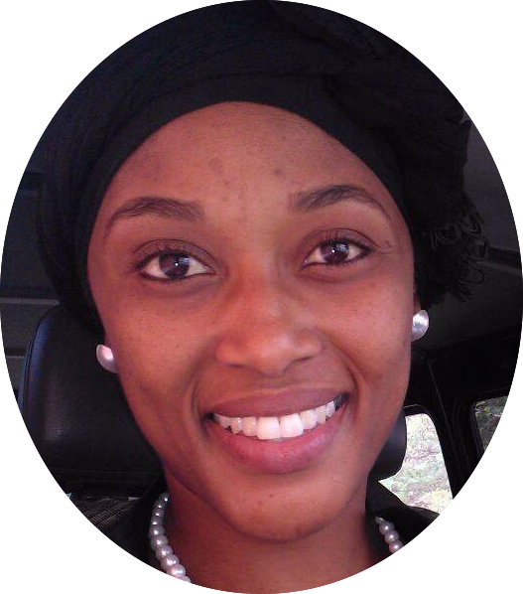Tefo  P. E Teacher  Profile  I am a married woman born in 1986 and share the same qualifications with my husband. We have a son born in 2016. We share a great passion of sports, we love to teach and enjoy seeing children learning with proper discipline and developing into responsible adults.  Contacts  E-Mail: tefo.376665@2freemail.com  C/o-Phone: +971502360357  Skills  1. Massage  2. Rehabilitation  3. Coaching | Education  Bachelors Degree: 2014  Physical Education and Sports Science  I graduated with a bachelor’s degree in Physical Education and Sports Science from the International School of Physical Education and Sports (Cuba).  Experience  Sherlin. Bootle School, Abaco, Bahamas(Currently)  Basketball Head Coach  University of Botswana(2015-2016)  Post: Assistant Lecturer  Reason for leaving:Pregnancy and personal decision to take of my baby for two years.  Botswana Basketball Association: 2014-2015  Basketball Head coach (under 16 female national team).  Botswana Defense Force Basketball: 2014-2016  Basketball Head coach for the Ladies team  Rainbow School, Botswana: 2014-2016  Voluntary work (Basketball Head Coach junior girls)  Cuba(2010-2014)  In Cuba I did internship as a physical education teacher and coaching basketball after hours.  Antonio Guiteras Secondary School (Cuba):2010-2012 PE teacher Grade 11-12  Quintin Banderas Primary School (Cuba):2012-2014  PE teacher Grade 5-6  Martíres and Barbados Sports School (Cuba) 2010-2014  Assistant Basketball coach Havana senior boys team  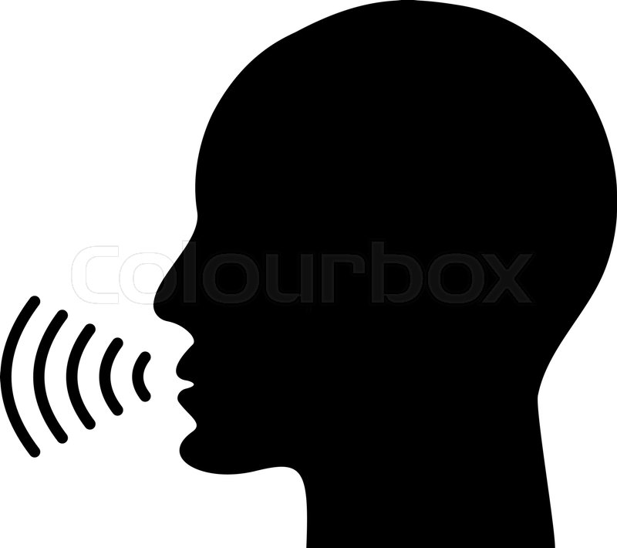Language  English: fluent  Spanish: fluent  Portuguese: basic  References, certificates and transcripts available upon request.

