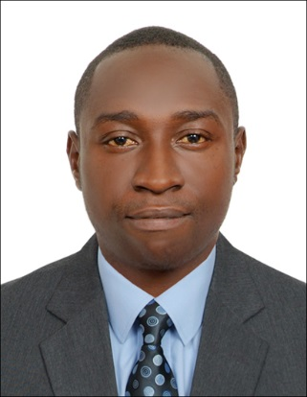
Francis
Abu Dhabi, UAE
C/o-Mobile No: +971503718643
Email Address: francis.376666@2freemail.com

POSITION:HOUSEKEEPER / CLEANER

CAREER OBJECTIVE:
A career where I will be able to contribute to the company’s growth. By utilizing my knowledge, educational skills and experience. So as to obtain a responsible rule in a quality oriented organization, using leadership and communication skills to help in my company,by doing all the work entrusted withme. Ensure quality service and provide innovation.

WORK EXPERIENCE:

- Camille clean.samgmelima (cameroon) 2016 to 2017

- High standard office and home cleaning. Including general maintenance of furniture’s, inside and outside cleaning, garden maintenance and infrastructure.
- Deep cleaning of bathrooms, organizing,vacuuming and mopping all areas assigned.
- Car washing

- Work at siantou asgeneral helper. Yaounde (Cameroon) 2013 to 2015
- Helping and assist the staff
- Helping in personal computer maintenance

PERSONALS SKILLS:
- A fast learner with great deal of motivation
- Work well under pressure
- Hard working efficient, honest and challenges
- Acceptance of all responsibilities and challenges
- Polite, respectful and courteous manners …
PERSONALS DETAILS:
Date of Birth : 11/06/1988
Gender : male
Nationality : Cameroonian
Marital Status : single
Visa Status : Visit visa

passport validity : 13 September 2022
EDUCATION:
- 2015. Siantou Higher Institute Cameroon. Higher National Diploma in Computer Maintenance
- 2012. LyceeBilingue de Mendong. Cameroon. Baccalaureate (GCE Advanced Level)
- 2010. LyceeBilingue de Mendong. Cameroon. Probatoire
- 2006.Lyceed’Emana. Cameroon. BEPC (GCE Ordinary level )
- CEP ( Primary School Leaving Certificate)
LANGUAGES PROFICIENCY:
- English Basic
- French Excellent
DECLARATION:
I hereby declare that the above information is true and correct to the best of my knowledge.

Francis

