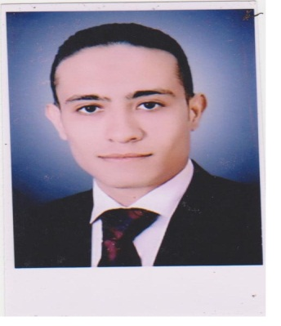May 2003May 2003

* Worked in **“October pharmaceutical Co.”** as medical representative on pharmaceutical prdoducts. **“Egypt**
* Worked in **“October pharmaceutical Co.”** as medical sales supervisor pharmaceuticalprdoducts. **“Egypt**
* Worked in “**Arabian Trade House** “ as product specialist on**medical devices branch « Anesthesia unit»**
* Worked in “**Arabian Trade House**” as sales supervisor

On Medical devices brance

* Worked in **Istanbul WorledHair** as a call center (**Turkey**)

**I have many traning courses in GENEVA , OMAN and BAHRIN

Dec 2006 –Dec 2010

Jan 2011 ــ May 2013

Aug 2013 – Nov 2015

Dec. 2015ــ Jun 2017

Aug. 2017- Des 2017

Shafey

UAE , Dubai ,Alnahda 1

[shafey.376668@2freemail.com](mailto:elshafey_1983@yahoo.com)

C/o- +971501685421

tourist visa

Name:

Address:

Email:

Phone:

Visa

Seeking a challenging position with a progressive company that will effectively utilize my communication, interpersonal, business and creative skills I can gain new experiences, develop new skills, learn and approach other cultures.

Bachelor of science, microbiology Dept.

Al-Azhar University, Assuit, Egypt.

Good.

Postgraduate of microbiology“Good grad”

Now I’m studying master of business administration online

May 2005

Grad

2007 -2010

2006 - 2007

Formal Education

Work Experience

Objective

Curriculum Vitae



Excellent withSaudi drivinglicence.

* Hyper-active, so precise, eager to learn, hard worker, dynamic, extrovert, nice & strong character, loyal, ambitious, Excellent communication & negotiation skills.
* Show excellent activity when work in group as a teamwork.
* Arabic: (Native).
* English: Very good Speaking, Reading and Writing.

Expert Institute course (American Language).

Photographing, My mobile, Ideas, fun , selected news, being updated & Career development

03 / 05 / 1983.

Male.

Married.

Exempted.

Egyptian.

* Excellent in Windows XP, Office (Word, Excel and powerpoint).
* Internet searching.

Interests

Personal Details

Date of Birth:

Gender:

Marital Status:

Military Status:

Nationality:

Personal features

Driving Skills

Computer Skills

Languages skills