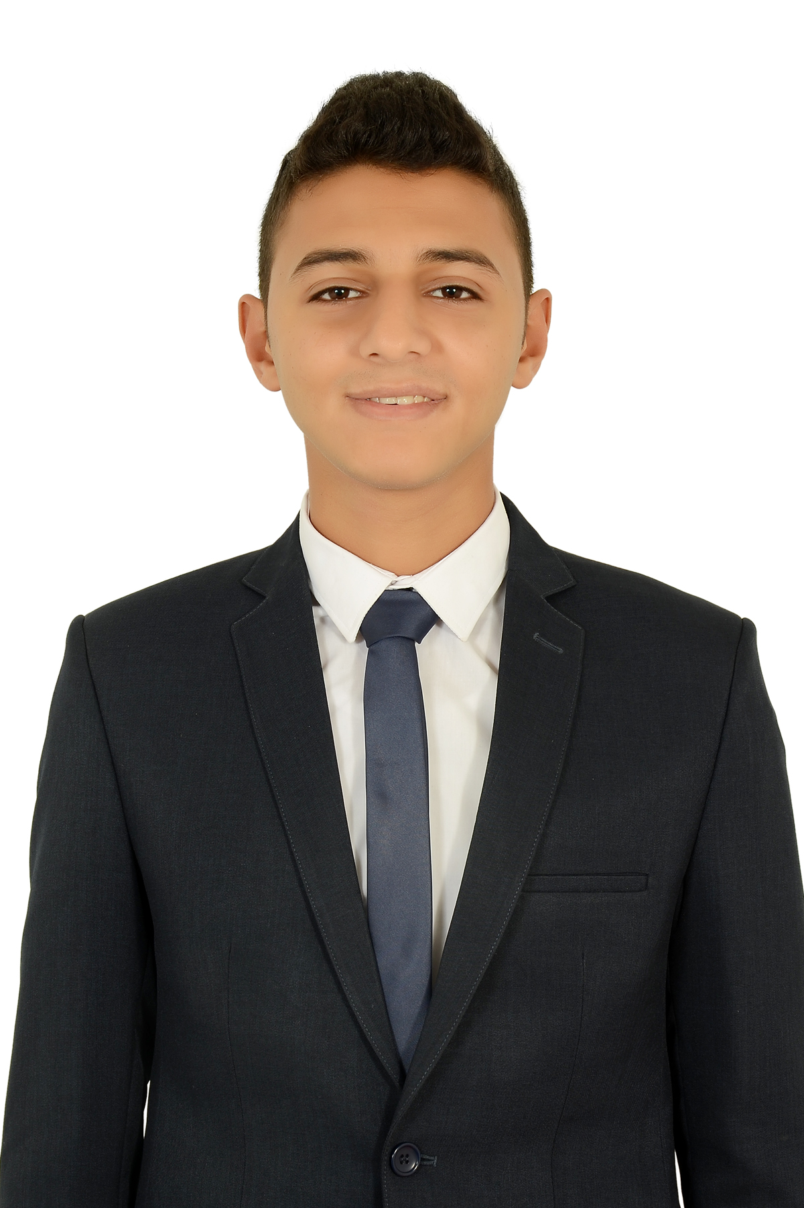  Mina |  | C/o-Phone: +971502360357  Email : mina.376686@2freemail.com  Bottom of Form
PERSONAL | Date of Birth: August 11, 1994 ( 23 years old )  Place of Birth: Cairo , Egypt  Citizenship: Egyption  Visa Status: Tourism Visa  Driving License: Available ( International license )
OBJECTIVE | IT Support Administrator , Sales , Customer Service , Facilitator
EMPLOYMENT | First Company , WWW.WELLSPRINGEGYPT.COM  January 15, 2014 – 2017  Leadership Program Coordinator  Worked in Wellspring Egypt as challenging ropes Head, directing ropes events, co-director for the sports camps, helping the leadership teams and committees ( part timer )  Certified Ropes Course Global Facilitator  - Applying safety regulations.  - Certified trainer, and solo saver.  - Conveying life values through ropes course (Experiential learning methodology)  Second Company, FACILITATOR AT DALE CARNEGIE EGYPT  January 1, 2016 – july , 2017 ( part timer )  Third Company, FACILITATOR AT 360experientialsolutions  January 1, 2016 - may, 2017 ( part timer )
EDUCATION | MODERN ACADEMY FOR COMPUTER SCIENCE , EGYPT  - Major : Information System ( Certified Certificate From Embassy)  - Fresh graduated  COURSES  - MCITP ; Microsoft Certified IT professional.  - Infrastructure ( fair knowledge .)  - Active Directory ( very good knowledge ) .  - CCNA Security ( very good knowledge ) .
SKILLS | Language  - Arabic : Mother Tongue  - English : Intermediate  - Italian : Fair .  Computer Skills  - Proficient user of Microsoft office applications, Search Engines and Social Media Channels .  - IT knowledge both in hardware and software .  - Install, Maintain and troubleshoot windows (2003 professional , Windows server 2008 – XP Home , professional, vista, 7 and windows 8 ) .  - Ability to reach the reason of hardware problems in workstations .  - Good knowledge of Internet .  - Using Internet to search for new technology and get solution for problems .  - Fair knowledge of VMware .  Personal Skills  - Good customer service skills .  - Ability to learn new technologies.  - Strong Analytical & Problem Solving Skills .  - Team Worker .  - Very Good Communication Skills .  - Handle customer’s problems and Objections.  - Effective interpersonal skills.  - Fast Learner.  REFERENCES FURNISHED UPON REQUEST

