66-128.pngphone1-128.png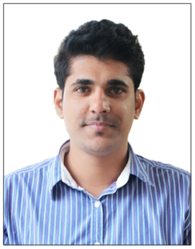

**C/o- +971 506425478**

[**Praveen.376688@2freemail.com**](mailto:Praveen.376688@2freemail.com)

## PRAVEEN

## Travel Counselor



**PROFILE**

An enthusiastic Travel Consultant with more than four years of experience in corporate travel deskand consultations looking forward for a suitable opportunity in a reputed organization for which sky is the limit for growth.



**EXPERIENCE**

**Travel counselor**

**Carlson wagonlit travel -**

As a part of the Corporate Travel team handle travel desk and assist Employees with their travel needs on International & Domestic Air Ticketing /Hotel /Insurance.

2016 > Current

**Ticketing Executive**

**Akbar Travels of India -**

Organize, schedule and book travelling tickets in accordance with individual travel plans and provide tourists with travel information and ticket booking details.

2014 > 2016

18-128.png

**KEY SKILLS**

* Sound knowledge in ticketing methods and softwares like Galileo & ABACUS (SABRE).
* Adept in tour operations (inbound) online Air Ticket and Train Ticket booking.
* Ability to multi task at Implant travel desk location similar to Air Ticketing Counter
* Daily usage of IATA ticketing knowledge in day to day work using Galileo GDS



**EDUCATION**

**IATA/UFTAA foundation course**

Passed IATA/UFTAA, course covering airfares and ticketing, tour operation, itinerary planning, electronic booking tools and Hotel industry topics.

**Travel and Tourism management**

Bachelor administration in Tourism principles, practices and trends, currency conversion and codes followed by the world tourism boards, from KANNUR UNIVERSITY. Course covered on the job training on various star hotels and travel agencies

**Commerce**

Pre degree equivalent that studies about subjects including business management, accountancy, statistics and economics

**IATA / UFTAA**

2014

**Bachelors Degree**

2009> 2012

**Higher Secondary**

2007 > 2009

**LANGUAGES KNOWN**

* To Speak : English, Hindi , Malayalam and Tamil
* To Read : English, Hindi & Malayalam.
* To Write : English, Hindi & Malayalam.

**PERSONAL INFORMATION**

* Date of birth : 28-01-1991
* Sex : Male
* Nationality : Indian
* Marital Status : Single
* Visa status : Visit