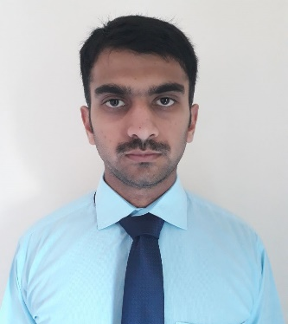
Ansar Visa status: Visit
Email: ansar.376701@2freemail.com MBA 3.5 years in Finance
Address :Dubai 2 years experience in accounting.
C/o-Cell no: +971504973598 Proficient in Microsoft Excel and peach tree.
Objectives:
Looking forward for an opportunity to work in a challenging environment, where I can utilize my knowledge skills in contribution effectively to the success of the organization and also for the improvement of my personal skills.
Professional Experience:
- Organization: Nestle Distribution (December 2015 to May 2017)
Department: Accounts and Finance
Position: Assistant Accountant
Job Description:
- Daily Stock report to the Manager.
- Daily Cash Sale of Products.
- Issue and Receiving of Products and ensure that the quantity of Products is fulfilled.
- Making Salaries of Employees.
- Daily Conversion Report.
- Data entry of Stock in Microsoft Excel on daily Basis.
- Manage day to day expenses.
- Maintain all record of Products available in Stock.

- Organization: Gelaf Carton Boxes Manufacturing LLC UAQ.UAE

Department: Accounting and Finance
Position: Assistant Accountant
Job description:
- Daily Cash Sale report to Manager.
- Make Recovery Statements of customers.
- Fill cheque slips for deposit Checks in Bank.
- Request the banks to issue new cheque books.
- Manage Day to Day expenses and report to Manager.
- Maintain all record of Office.
- Maintain daily over time of employees.
- Maintain Daily Conversion report.
- Receive Stock and Balance then total raw material received from companies.
Tools:
- Microsoft Excel
- Peach tree
Qualifications:
Education | Institute
I.Com | Punjab college of commerce Gujranwala, Pakistan
B.Com | University Of Punjab, Lahore, Pakistan
MBA (3.5 Years) | University Of Gujrat, Pakistan

Certificates:
6 weeks Internship in Pepsi Cola International.
Merit laptop by Government of Punjab
Peach tree Training.
Skills & Capabilities:
Proficient in MS Word, MS Power Point and MS Excel
Peachtree Accounting Software
Communication Skills
Interests:
To learn something new every day
Reading newspaper
Surfing Internet
Languages:
English, Urdu, Punjabi
Personal information:
Date of Birth: - 22-February 1991
Nationality: - Pakistani

