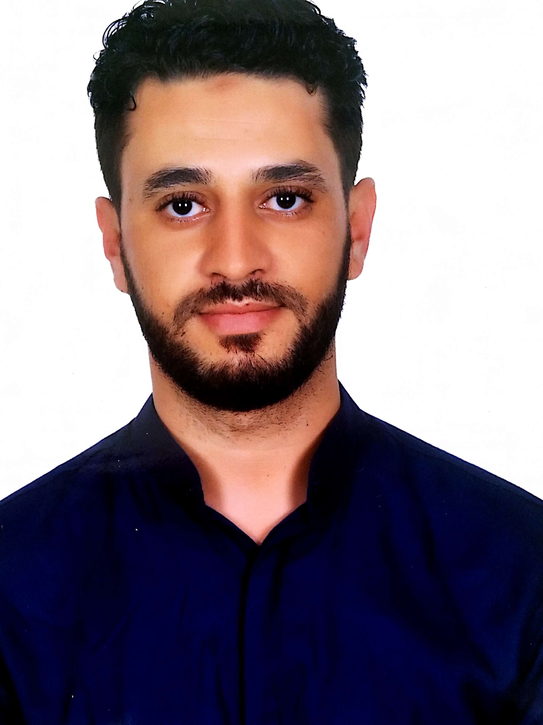

ANAS

C/o-Mobile : +971501685421
Email : anas.376704@2freemail.com

DRAFTSMAN and Senior Field Surveyor

Personal information:-

First name/Surname : Anas
Date of birth : February 12, 1990
Date of place : Rabat, Morocco
Marital Status : Single

Objective:

Seeking an assignment as Draftsman (Engineering Designer) and/or Senior Surveyor with an organization of high repute in Infrastructure/ Construction in Middle East countries.

Skill Set:

- Deft in working with Auto CAD
- Preparation of Civil Detailed drawing like Plan, Section, Elevation, Structural details, Shop Drawings, Detailed Landscaping and Irrigation Drawings.
- Familiar with Microsoft Excel Spread Sheets for Calculations, Microsoft Word, Microsoft Power Point
- Ensuring accurate CAD drawings in as par with company and client’s standards
- Good Experience in preparation of Quantity from drawings.
- Maintaining all the Drawing Status and Drawing list of Projects.
- Ability to prepare neat and accurate drawings in AutoCAD such as structural drawings, rebar detailing, concrete outline and as built drawings.

Work Experience

Period from : March 2013 - Ongoing
Detail of Employer : Omar Bourhrara Engineering Office
Type of business : Construction, (Building and Infrastructure)
Position held : Draftsman and Senior Field Surveyor

Main activities and responsibilities

- Preparing Structural general arrangements drawings.
- Prepare drawings for erecting equipment’s, Tower crane layout.
- Prepare detail drawing for the construction.
- Shop drawings for rebar work.
- Preparation of as built drawings, Logistics drawings for the project.
- Preparing coordinates for surveyor.
- Checking and Setting out of Boundary wall, column and structure work for all villas.
- Checking of TBM, Reference pillars.
- Checking of roof screed and Garage slab
- Reference level marking of all villas for work of block work, mechanical electrical and plumbing work (MEP) and tile and marble work.
- Preparation of Drawings, Road layout ,Drainage layout ,Fire water lines, Plot Plan, steel and Structural details
- Sectional elevations, as built drawings.
- Consulting with the Architects & Engineers during the design phase and using their -feedbacks for modification of the design.
- Guiding the subordinates regarding efficient and effective drafting –techniques.
- Ensure accuracy of all drawing works through CAD Numbering System.
- Responsible for the maintenance of all technical & engineering drawings.
- Visiting site and Making all for the Mark up drawings.
- Printing, plotting, scanning, copying, etc.
- Taking quantities for Indent and Billing.

Period from : February 2011- March 2013
Detail of Employer : Ahmed EL AATAR Architecture Company
Type of business : Construction, (Building and Infrastructure)
Position held : Draftsman and Senior Field Surveyor

Main activities and responsibilities

- Preparing Structural general arrangements drawings.
- Prepare detail drawing for the construction.
- Sectional elevations, as built drawings
- Shop drawings for rebar and carpentry works.
- Preparation of as built drawings, Logistics drawings for the project.
- Preparing coordinates for surveyor.
- Checking and Setting out of Boundary wall, column and structure work for buildings
- Reference level marking of all villas for work of block work, mechanical electrical and plumbing work (MEP) and tile and marble work.
- Taking quantities for Indent and Billing.
- Preparation of Drawings, Road layout ,Drainage layout ,Fire water lines, Plot Plan, steel and Structural details
- Guiding the subordinates regarding efficient and effective drafting –techniques.
- Responsible for the maintenance of all technical & engineering drawings.
- Site control and confirm all for the Mark up drawings.

EDUCATIONAL QUALIFICATIONS:

Period : September 2012 – July 2013
Qualification awarded : Diploma in Topography at the institute of technicians
Specialized in topography and rural engineering of MEKNES

Period : June 2011- July 2012
Qualification awarded : Diploma Technical Draftsman of Building of ISTA HAY NAHDA
(TDB)

Period : September 2007-June 2010
Qualification awarded : Bachelor's degree in Physical Science and Chemistry

Languages Known:

English (Fluent), French (Fluent), Arabic (Mother Tongue)

Computer skills and competences:

AutoCAD, Topogen, MS Office, Outlook, Windows.

Driving License:

Moroccan

