FATIMA
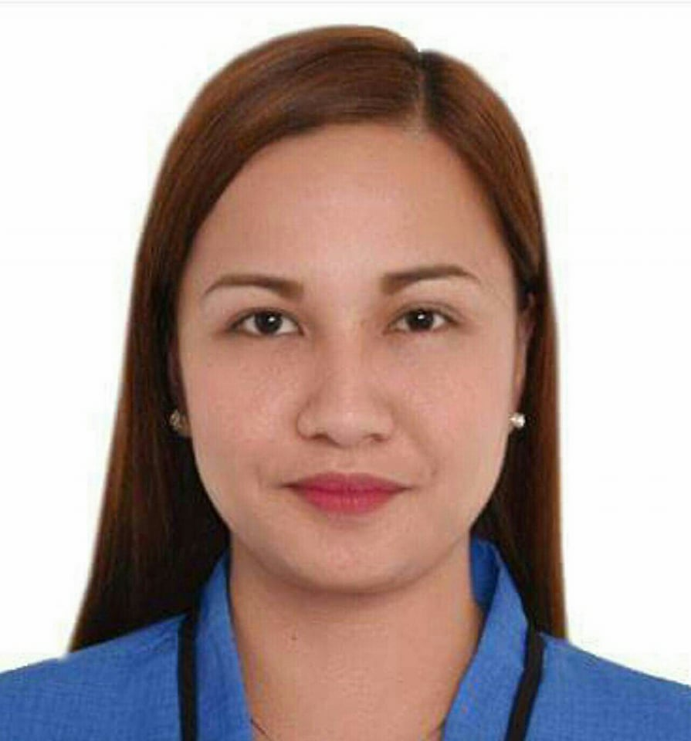
Address: Sharjah, UAE
Mobile: C/o 971504973598
Email: Fatima.376728@2freemail.com

OBJECTIVE

Seeking an opportunity to use my skills, apply all my knowledge and further utilize it to achieve professional growth while developing myself as an individual which would allow me to contribute and be a valuable asset to your organization.

QUALIFICATIONS AND SKILLS

- Good command over English – Written and Spoken.
- Excellent in Public Relations and Customer Service.
- Good in Decision Making and Can Handle Pressures.
- Hardworking, Well Organized, Initiative and Responsible Natured.
- Experience in Office Administration Work.
- Knowledgeable in Banking Operations.
- Good Knowledge in MS Office and having good speed in typing.
- Computer Literate.

WORK EXPERIENCE

SAN ANTONIO WATER DISTRICT
February 13, 2017 – Present
Position: Storekeeper

Duties and Responsibilities:

- In-charge of the issuance of material and office supplies.
- Maintain stationary stocks.
- Any other task request by General Manager.

NEW RURAL BANK OF SAN LEONARDO INC.
January 20, 2014 – February 03, 2017
Position: Bank Cashier

Duties and Responsibilities:

- Ensure CIV is at sufficient levels to meet daily & anticipated transactions.
- Cash count and cash transfer to Teller at day’s beginning.
- End-of-day’s receipt of cash from from Teller and cash count.
- Checks that are due for deposit are carried out.
- Prepares requests for payment (RFP’s) including client check withdrawal
- Anticipate any big withdrawals.
- Monitor maturity & roll-over of BTD & GPS & alert BM and Treasury Dept. about it.
- Conducts tellering job when the Teller is not available or absent.
- Ensure all bills are paid on time.

MUNICIPALITY OF SAN ANTONIO
February 16, 2012 – June 30, 2013
Position: Executive Secretary

Duties and Responsibilities:

- Attending telephone calls.
- Personal assistant to the Municipal Mayor.
- Arrange and confirm appointments.
- Assisting and entertaining visitors.
- Maintain scheduled calendars.

SEMINARS AND TRAININGS

CASH OPERATION AND AMLA (Anti-Money Laundering Act)
Bishop J.X. Labayen Ceneter, San Leonardo, Nueva Ecija, Philippines
February 22, 2014
USSC (Western Union)
Marry’s Hotel & Restaurant, Cabanatuan City, Nueva Ecija, Philippines
May 24, 2014
SIGNATURE VERIFICATION, BANK FRAUD AND CURRENCY DETECTION
Bishop J.X. Labayen Ceneter, San Leonardo, Nueva Ecija, Philippines
May 31, 2014

HR POLICIES AND PROCEDURES
Bishop J.X. Labayen Ceneter, San Leonardo, Nueva Ecija, Philippines
July 19, 2015

CASH OPERATIONS AND RELEVANT BSP (Banko Sentral ng Pilipinas) CIRCULARS
Bishop J.X. Labayen Ceneter, San Leonardo, Nueva Ecija, Philippines
August 02, 2016

EDUCATIONAL QUALIFICATION

Degree: Bachelor of Science in Information Technology
University: College of Immaculate Concepcion – Cabanatuan City, Philippines
Graduated: 2005-2009

PERSONAL INFORMATION

Date of Birth: May 13, 1989
Age: 28
Gender: Female
Nationality: Filipino
Height: 5”2’
Weight: 121 lbs.
Civil Status: Married
Religion: Roman Catholic

CHARACTER REFERENCES

Available upon request.

