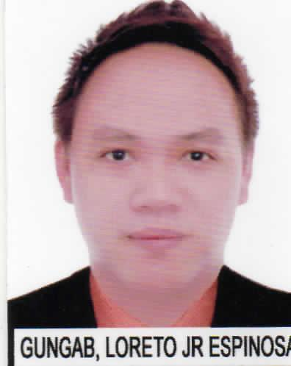
LORETO
Address: Sharjah, United Arab Emirates
E-Mail Address: loreto.376738@2freemail.com
Mobile Number: C/o 971501685421

Objectives:
- To obtain a rewarding job and work effectively and competing with the best, seeking knowledge, wants to continue my career with the respectable company.

Relevant Skills:

- Excellent Communication Skills
- Friendly and Confident manner with pleasing personality
- Energetic and able to work under pressure
- Customer Service Oriented

Professional Experiences:

- September 2012 – September 2017
Alorica Clark
Clark Freeport Zone, Pampanga, Philippines
Customer Service Representative (T-Mobile)

- Responsible in Customer Service (T-Mobile).
- Responsible of taking inbound calls.
- Responsible in answering customers questions about their accounts and technical related questions.
- Bill Account Specialists
- Responsible of giving satisfactions to customer experience.
- Responsible in giving customer the best quality service.
- Self-Correspondence.

- June 2012 – August 2012
Time Square Telesales (Direct Home)
Angeles City Pampanga Philippines
Outbound Sales Representative

- Make outbound call for customer to offer products.
- Check available leads.
- Set appointment for customer who wants to visit showroom.

- February 2011 – May 2012
UPS International, Inc. (Logistics)
Clark Freeport Zone, Pampanga, Philippines
Customer Service Representative

- Responsible of locating shipping address.
- Responsible of taking inbound calls.
- Responsible of scheduling shipment pick-ups, tracking and billing packages.
- Responsible in providing good customer services.
- Self-Correspondence.

- October 201 – January 2011
Sutherland Global Services
Clark Freeport Zone, Pampanga, Philippines
Customer Service Representative (target.com)

- Responsible in taking inbound calls.
- Responsible in assisting customers with their queries about their online shopping accounts and orders.
- Responsible in providing good customer services.
- Self-Correspondence.

Education:

- Collegiate: Bachelor of Science in Nursing
Dee HwaLiong College Foundation
Angeles City, Philippines
Batch 2008

Personal Data:

- Date of Birth: May 02, 1987
- Place of Birth: Angeles City, Philippines
- Age: 30
- Civil Status: Single
- Citizenship: Filipino
- Visa Status: Visit Visa
- Date of Entry: January 08, 2018

I hereby certify that all given information are true and correct with the best of my knowledge and belief.

Loreto

