RESUME

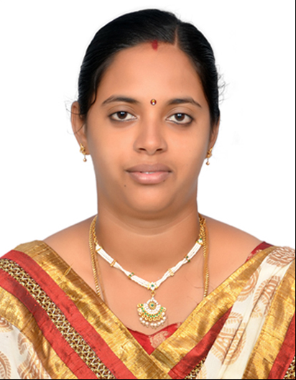

AHILA
PRESENTLY: Sharjah – UAE
PHONE: C/o 97150236357
Email: ahila.376746@2freemail.com

OBJECTIVES:
Looking forward to apply acquired teaching skills & Facilitate the student interests in Science & Tamil Language.

PERSONAL PROFILE:
Date of Birth : 18.03.1992
Gender : Female
Marital Status : Married
Nationality : Indian
Linguistics : Tamil & English

PASSPORT:
Date of Issue : 28.12.2013
Date of Expiry : 27.12.2023
VISA DETAILS:
VISA Details : Sponsor by Husband
Date of Issue : 11.10.2017
Date of Expiry : 10.10.2020

EDUCATIONAL QUALIFICATION:
ACADEMICS:
- MASTER OF SCIENCE IN PHYSICS
Duration: 2012 - 2014.
Passed with 68% of Marks
MOTHER TERESA WOMENS UNIVERSITY
KODAIKANAL, TAMIL NADU, INDIA – 624101.

- BACHELOR OF SCIENCE IN PHYSICS
Duration: 2009 - 2012.
Passed with 69% of Marks
MOTHER TERESA WOMENS UNIVERSITY
KODAIKANAL, TAMIL NADU, INDIA- 624101.

WORK EXPERIENCE:

Job Titles: Teacher (Full Time Job at Private school)
As Science Teacher : For VIIth Std
As Class Teacher : For IVth Std
Worked For : MSR Matriculation Higher Secondary School
Place : Madurai, Tamilnadu, India - 625702
Worked Period : June 2015 to April 2016

Job Titles: Physics Teacher (Part Time Job at Private Study Center)
As Physics Teacher : For 12th Physics (English & Tamil Medium)
As Science Teacher : For 10th Std (English & Tamil Medium)
Worked For : MEERA Tuition Center
Place : Madurai, Tamilnadu, India - 625705
Worked Period : June 2015 to Aug 2017

SPORTS & ACTIVITIES:

VOLLEY BALL PLAYER: More than 5 years as a player. Played for my School & Collage, District Level.

YOGA : Practiced for 1 year & Doing Regularly.
Able to Teach Basic level for students.

This is to certify that the information submitted above is true and correct to the best of my knowledge & belief, nothing has been concealed or distorted.

By

AHILA

