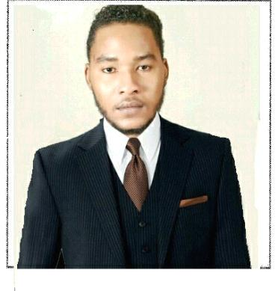
Alameen

Ophthalmic Optometrist & Technician

at Sudan Eye Hospital Sudan

L Location Dubai, United Arab Emirates

Education Education. Optometrist and technologies

Experience 3 Years, 5 Months

CONTACT

Name: Alameen

Mobile Phone: C/o 971501685421

Location Dubai, United Arab Emirates

Email Address: alameen.376766@2freemail.com

TARGETJOB

Target Job Title: Certified Ophthalmic Optometrist & Technician

Career Level: Mid Career

Target Job Location: UAE

Career Objective:

Diagnose, manga, and treat conditions and disease of the human eye and visual system, Examine eye and visual system, Prescribe eyeglasses and contact lens,

work over this investigation (.FFA-.Fundus Flourescin Angiography, Optical Coherence Tomography ( OCT ).

Employment Type: Full Time Employee; Contractor; TemporaryEmployee; Part Time Employee; Commission

PERSONAL INFORMATION

Birth Date 1 June 1994 (Age: 23)

Gender Male

Nationality Sudan

1/3

EXPERIENCE(3 YEARS, 5 MONTHS)

February2012 - June 2013

Ophthalmic Technician & Optometrist

M akkah Eye H osp ital-Kh artou m -SUDA N

Responsible for

- Diagnose, manga, and treat conditions and disease of the human eye and visual system

- Examine eye and visual system

- Prescribe eyeglasses and contact lens

March 2014 - March 2016

Ophthalmic Technician & Optometrist

( Sudan Eye Center )Khartoum - Sudan

Responsible for

- Testing and measures eye function to assist Ophthalmologist to diagnose and treat eye disorders and disease

- Tests patients far acuity ,near acuity, peripheral vision, depth perception and colour perception

-Examine eye using Slit lamp for abnormalities of corner and interior and posterior chambers

- measures intraocular pressure of eye .

- M easu rin g axial len gh th of eye

- op tic sh op s

June 2016 - June2017

Ophthalmic Optometrist & Refraction & Optical Shop

( M agrabi Eye H osp ital ).Egyp t

Responsibility

- performing testing and measurements as required

- work over this investigation (.FFA-.Fundus Flourescin Angiography )

  - Optical Coherence Tomography ( OCT ). (A&B scan ) ( IOL Master)

QUALIFICATION

201 3 Higher Diploma , Of Optometrist & Technician

at Makkah Eye College SUDAN

Completed the university education and obtaines Higher Diploma in Eye Investigation And eye exams

2/3

2014 Master of Ophthalmic Technician and Assistan

IJCOAHP ( Joint Commission On Alled Health Personnel

In Ophthalmolgy ( IJCAHPO )

Completed the education an obtained Master of Ophthalmic Technician and Assistance (COT & COA)

Sep t 2011 Fundamentals And Principles Of Nursing

Afia Med ical of Exp erience SUDAN

Course covered theoretical and practical of Nu rsing And Fu nd amentals

MAY 2016- Training Courses in the Ethics of the Medical
Profession and Health Personnel in Ophthalmology

Su d anese National Cou ncil of Med ical & Health Professionas

Cou rse Covered theoretical and p ractical

of med ical and hu man health

Language

Arabic ( native ). English ( native) French ( intermediate)

3/3

